Report of the
Facilitation Workshop on
DAVP Empanelment for
Community Radio Stations
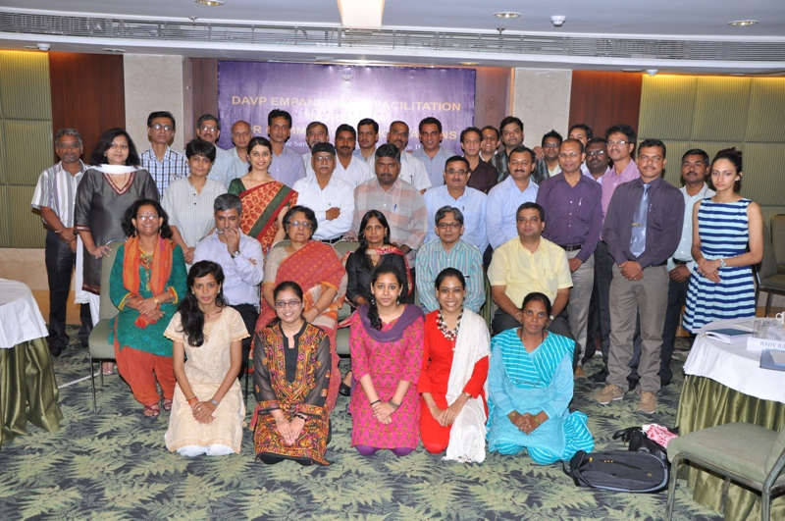

New Delhi
August 5, 2013
Background
With a view to provide a catalytic push to the sustainability of community radio operations, CEMCA Community Radio Facilitation Centre (CCFC), supported by Ford Foundation, has been guiding and facilitating a number of CR Stations to apply to the Directorate of Advertising and Visual Publicity (DAVP) for empanelment to receive advertising support from government agencies over the past two years . Out of the thirty six CRS empanelled with DAVP, 25 were done through CCFC , who have also helped another 11 CRS to complete the process. Continuing this pro-active approach, CCFC invited around 30 CRS drawn mostly from the NGO sector, who fulfill the DAVP eligibility criteria for a one day workshop at Delhi on July 30, 2013 to provide on-the-spot facilitation to get them empanelled with DAVP. Besides the CCFC staff, four interns were invited to help with the empanelment process.

Workshop Objectives
- To facilitate the invited CR Stations to become empanelled with DAVP
- To provide an opportunity for CRS to interact with senior officials from DAVP and the Ministry of Information and Broadcasting (MIB) during the empanelment process

Workshop Participants
The CR Stations invited to participate in this workshop had already evinced an interest and requested CCFC support to empanel their CRS with DAVP. Before coming to the workshop, the participants were asked to send complete details required for filling in the online application including the annexes required to be attached. Only those organisations which had fulfilled all the requirements were invited to the workshop. Out of the 29 CR Stations drawn mostly form NGO sector invited to the workshop, 27 CRS participated. (Please see List of participants in Annexure I).

Workshop Proceedings
Inaugural Session
After a round of introductions Director CEMCA, Dr Sanjaya Mishra welcomed all participants and shared the importance of the work of CCFC in facilitating the licensing process and developing toolkits for strengthening CR Sector. He emphasised the yeomen service and leadership of Ms Supriya Sahu, Joint Secretary, Broadcasting, Ministry of Information and Broadcasting (MIB), and her steering the CR movement. He reiterated the continued interest of CEMCA in engaging on important development activities of CR movement.
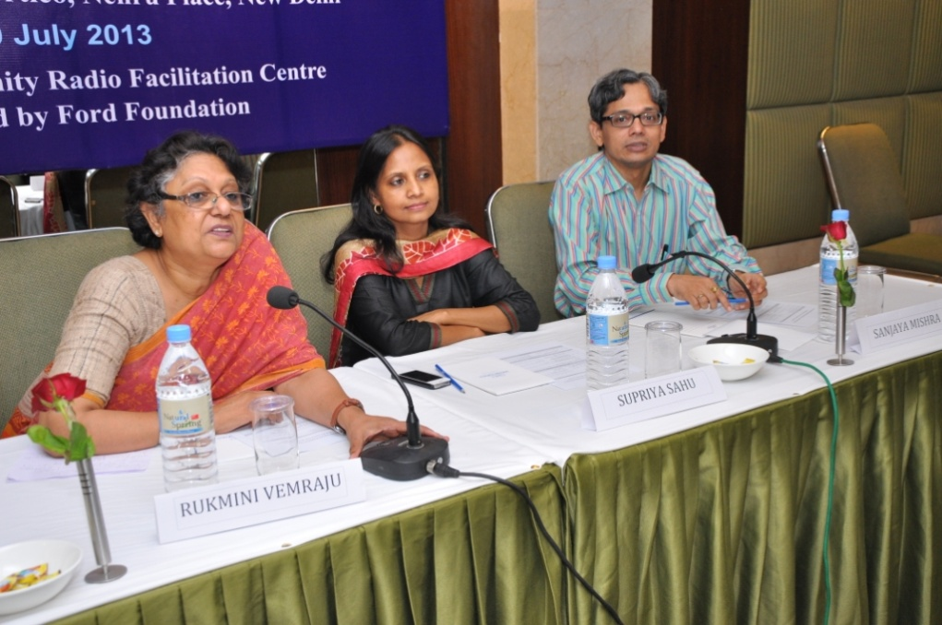
Ms Supriya Sahu while thanking the Director CEMCA also thanked the officers of DAVP present and recognised the important role played by Mr Nag and Mr Rastogi of DAVP to make sure that flexibility and encouragement is provided in considering applications from CR Stations. She announced the successful clearance of the CR Fund of Rs 100 crore for the next four years of the 12th Plan Period under which resources will now be available not only for new CRS to be established (contributory funds) but also for existing CRS to upgrade or augment their technical infrastructure and resources.
She added that emergency funds have also been earmarked to ensure that natural disasters like flood, lightening, etc. that cause damage to transmitters and shut down operations can be re-hauled with such funds. Other activities include extensive awareness generation activities, outreach, and capacity building activities. She thanked Rukmini Vemraju and the entire team of CCFC for leadership and continued support to the CR Movement, including some members present in the forum who have been part of the CR Fund Working Group and helped to draft the fund and then to a scheme.
Ms Rukmini Vemraju outlined the key objectives of the workshop, namely to ensure that sustainability of CRS can be ensured by having more CRS empanelled with DAVP, and the aim is to get as many of the invited participants empanelled as possible. The meeting broke for tea after a group photograph with the guest of honour.

Technical Session on DAVP Empanelment Process and Priorities
In the second technical session, Mr Madhu Nag and Mr Rajeev Rastogi, along with Mr Rajiv Tikoo of One World Foundation highlighted the key areas of their work and also responded to questions from participants. Mr Nag reiterated the importance of having more numbers of CRS in the panel to be able to provide this is a suitable medium for various development campaigns of client ministries. The departments that have evinced interest to reach the citizens through CR include: Disaster Management Authority, Consumer Awareness campaign (Jago Grahak Jago), Health, etc. he added. Other departments needed to be made aware about the value proposition of CRS to reach the last mile.
Mr Rastogi and Mr Nag also emphasized the importance of correct filling of forms, and pre-requisite information to get quick clearances and stated that they would like to make the system transparent and system-managed rather than needing agencies to come to the DAVP office, reiterating that they were accessible to any who were facing challenges and wanted an audience with them. In response to a participants query regarding delays in payment Mr.Nag conceded that the billing and payment system continued to follow the routine government process that was somewhat lengthy a lengthy process, and assured that he was available to address problems faced by CRS and guide them.
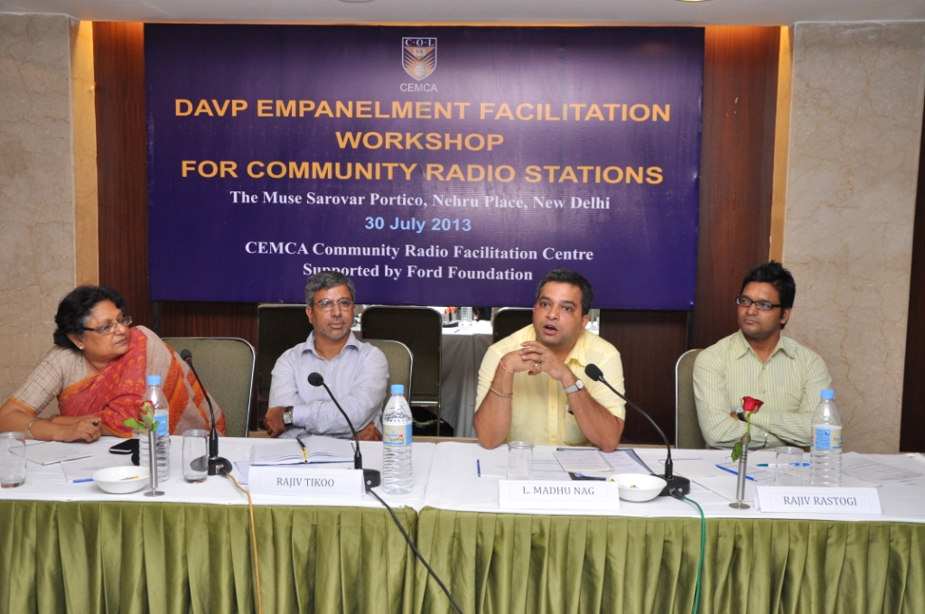
The DAVP team Rupica and the team at CCFC for providing continuous and unstinted back-office support to reach the numbers of 36 CRS empanelled and 12 in the pipeline. Assuring that for CRS, the empanelment was open throughout the year, and cases are put up within two weeks of submission of the proposals (complete online and hard-copy docs), he was happy to provide any specific help needed.
Following this session, Mr Rajiv Tikoo of One World Foundation (OWF) made a presentation on the work of the OWF and the direction that they are focused on, mainly four lines of business – documentation, strengthening capacities, use of technology, and governance. Reiterating that OWF was already engaged with CRS to train and build capacities of organisations to use community media for sharing their stories, he talked of their recent engagement in CR awareness activities (Sammelan, Compendium, workshops, etc.) and now to provide support to CR movement in the facilitation activities, as was announced by Ms Sahu earlier in the day that OWF will now take over the CCFC activities. He talked of the close cooperation between CEMCA and OWF in the EDAA platform and the production of content on specific thematic that was aired in All India Radio.
Ms Rukmini Vemraju while summarizing and thanking the panelists assured that the back-end aspects of facilitation will see a very smooth transition, including transfer of knowledge and resources, for the next phase to be handled by OWF making it seamless for the CRS. She once again thanked all present for their leadership and continued support to ensure that the CRS can get advertising support from DAVP.
Online Applications Process and Technical Session
(Facilitated by Interns and Project Associates)
In the session following lunch, the participants who had come prepared with a filled in format and details for online application for DAVP empanelment began their work. Four work stations were set up and activities relating to empanelment began with support of Interns present.
During this session, Mr Inderjeet Grewal, Dy Director (B) MIB and Mr Amarendra Rao, of the CR Cell joined the workshop for an open dialogue and addressed some of the issues and queries that the participants had in their minds.

Issue clarifications by Ministry of Information and Broadcasting
How do I get to open a Bank Account or PAN in the name of a Radio Station, when the license is actually in the name of the Organisation?
Answers:
- Submit a copy of WOL where the name of CRS is mentioned
- In Educational Institutions case, there is no additional proof sought since the banks have extension counters in the premises of universities at times and are aware of the project and management of funds/resources
- Register the name of CRS as a trademarked brand from Mumbai and this will help open a bank account in the name of the brand.
- You may call for a special board meeting of the NGO, with an agenda item and pass a resolution that we need to open a separate bank account, preferably with two signatories. This resolution should be in the minute book, and copy of this submitted to the Registrar of Societies and Bank to open a bank account.
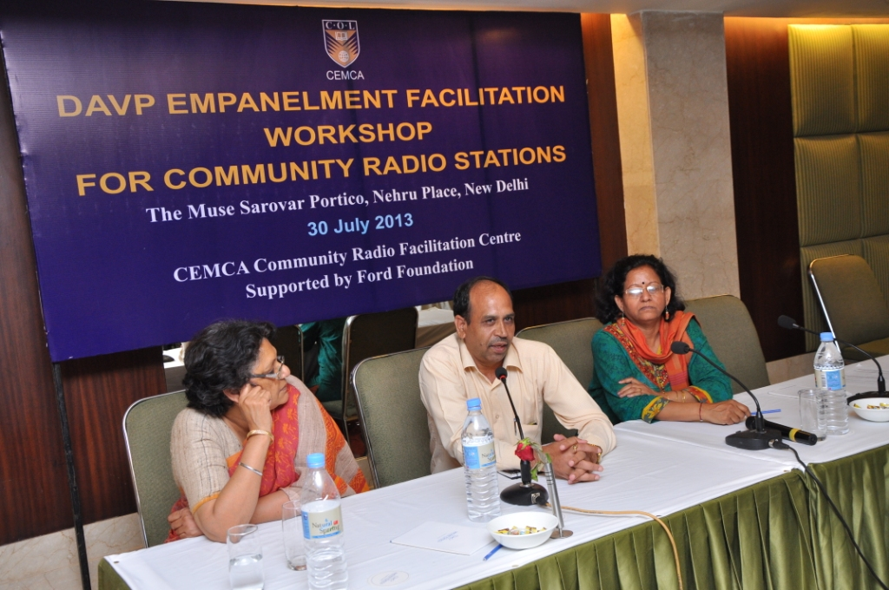

How do I get the GOPA renewal?
Answers:
GOPA lapsing and terms and conditions changing are being dealt with and MIB will be issuing a set of guidelines for the same. Meanwhile, CRS can write directly to MIB requesting GOPA renewal.
Can MIB write to WPC to adjust the excess amount paid by some CRS and roll-back?
Answer:
MIB will discuss and provide advise on how to request for an adjustment. Refunds may not be possible, but renewals may be allowed using reference of same DD number.
Can we sell old equipment like Antenna, since our frequency has changed?
Answer:
You can give it back to your vendor, or sell to another party. But, you are not permitted to sell the Transmitter, as it is sold to you only, and licensed for that use only.
In case your transmitter fails, and you have to replace, you need to write to WPC and make another request for the change of transmitter.
Mr. Grewal reiterated their ministry’s continued support for all CRS and assured them to make timely help to CRS as needed.
The workshop sessions on empanelment continued after tea.
Catalysing the DAVP Empanelment – Success Story
At the end of the session, the results were phenomenal!
While only two organisations from the original list of invitees could not participate in the workshop, of the 29 stations, 17 stations were empanelled at the end of the workshop (one new station was empanelled while they were not on list); and 9 stations were able to register online, but not complete the process due to one of the following reasons:
- DAVP site was not accepting the IFSC code of the bank accounts,
- CR Stations were awaiting the delivery of PAN cards, for which applications were already made
- CR Station did not have Service Tax Registration
A tracker and photography session in the end of proof of their completion was made making it a very lively process of accomplishment and celebration. The meeting ended with a vote of thanks for all interns who worked hard to support the CCFC team.

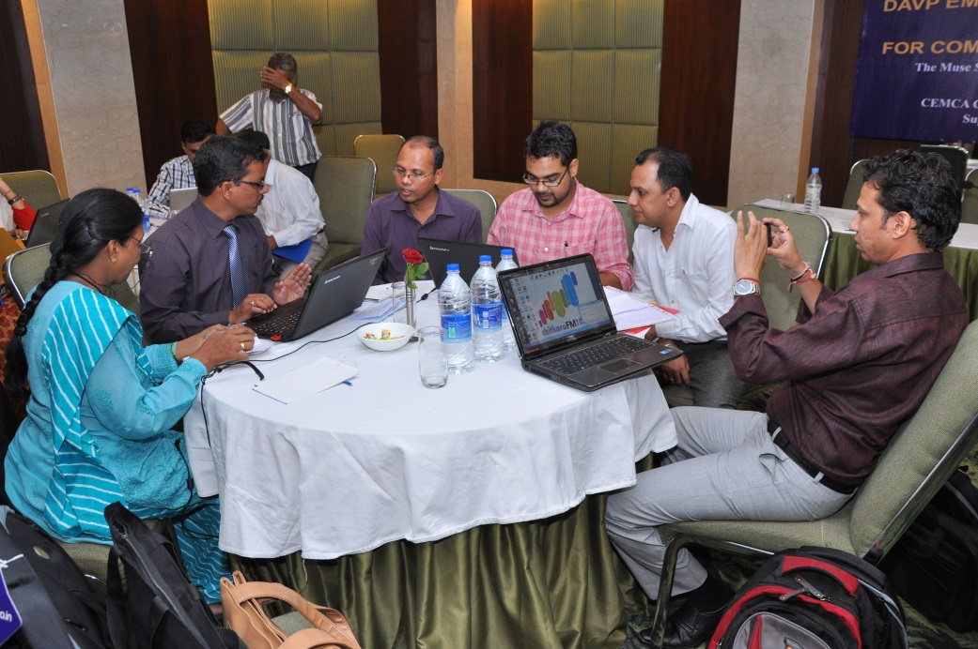

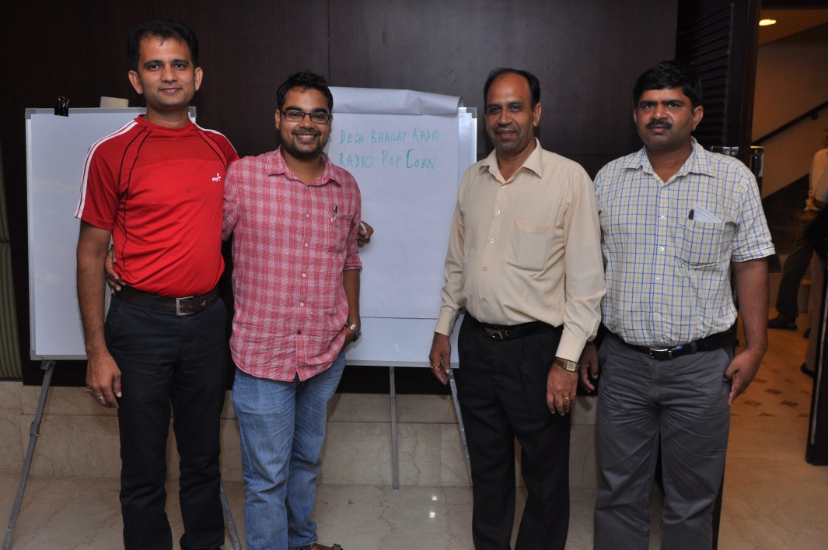
ANNEXURE I – LIST OF PARTICIPANTS
Facilitation Workshop for DAVP Empanelment
Hotel Sarovar Portico, New Delhi,
30 July 2013
S.NO | ORGANIZATION | PARTICIPANT | STATUS
1 | Radio Active  Lokhit  Jagannath Sudi Lane,  Mandroja  Bhagalpur-812002, Bihar | Mr Sandeep Kumar Pandey  +91-7549000912 | Empanelled Online
2 | Vivek CR  Vivek High School  Sector- 38 B, Chandigarh-160036 | Mr Ashish Tandon  +91-9888324878 | Empanelled Online
3. | Jana Dhwani  Viveka School of Excellence Education , Hanchipura Road, Saragur, HD Kote,  Mysore-571121, Karnataka | Mr M Seetharam  +91-9686666305 | Empanelled Online
4. | Jan Vaani  Academic & Technical Education Development Society (ATEDS)  Post Office Building, New Mahe,  Kannur-673311, Kerala | Mr Nirmal Raj  +91-8606609000 | Empanelled Online
5. | Kisan Vani Community Radio  Indian Society of Agribusiness Professionals  23, Zamrudpur Community Centre, Kailash Colony Extension, New Delhi – 110048/  Mandi Prangan, Begam Bag, Sironj, District Vidisha-464228, Madhya Pradesh | Mr Jitendra Sharma  +91-9319969042 | Empanelled Online
6. | KVK Pravara Community Radio  Krishi Vigyan Kendra (PIRENS)  Babhaleshwar, Taluka Rahata,  Ahmednagar-413737, Maharashtra | Mr Purshotam Hendre  +91-9860668892 | Empanelled Online
7. | Mann Deshi Tarang  Mann Deshi Foundation (Mannvikas Samajik Sanstha) Mhaswad, Taluka Mann  Satara-415509, Maharashtra | Mr Shivaji Maruti Yadav  +91-9403704767 | Empanelled Online
8. | Radio Nagar  Snehalaya  Dr. Adkar Bal Kalyan Sankul, Balkalyan Sankul Lendkar Mala, Balikashram Road, Ahmednagar-414001, Maharashtra | Ms Rupali Deshmukh  +91-9762864204 | Empanelled Online
9. | Kalanjiam Samuga Vanoli  Dhan Foundation  18, Pillaiyar Koil Street, S.S.Colony,  Madurai-625016, Tamil Nadu | Mr Naguveer Prakash  +91-9488008366/ +91-9042271293 | Empanelled Online
10. | Radio 7  India International Institute of Management  Sector 12, Mahaveer Marg, Manasarovar, Jaipur-302020, Rajasthan | Ms Preeti Tiwari  +91-8875003216 | Empanelled Online
11. | Green Community Radio  Sasneha Kala Krida Mandal  Shoe Pavilion, 1st Floor, Near Ram Mandir,  Miraj Road,  Sangli-416416, Maharashtra | Mr Sanjay Ranade  +91-9850571150 | Empanelled Online
12. | Kisan Radio  Kisan Seva Sanstha  Mahesh Bhawan, Awas Vikas Colony, Kartra, Gandhi Nagar,  Basti-272001, Uttar Pradesh | Mr Atul Shukla  +91-9415173162 | Empanelled Online
13. | Desh Bhagat Community Radio  Satguru Foundation  SCO 181-182, 2nd Floor, Sector 8-C, Chandigarh-160009 | Ms Richa Sharma  +91-9780777733 | Empanelled Online
14. | Salaam Namaste  Institute of Management Studies  A-8B, Block C, IMS Campus, Sector 62,  Noida-201303, Uttar Pradesh | Ms Barsha Chabaria  +91-9717411111 | Empanelled Online
15. | Radio Popcorn  RKDF Institute of Science & Technology  12 Jatkhedi, Hoshangabad Road  Bhopal-462026, Madhya Pradesh | Mr Mrityunjay Singhai  +91-9893448220 | Empanelled Online
16. | Vayalaga Vanoli  Madurai District Tank Farmers Federation  W5/565, MDCC Bank upstairs Trichy main road Kottampatti, Melur Taluk  Madurai-624103, Tamil Nadu | Sent documents through Kalanjiam CRS | Empanelled Online
17. | Vidyavani CR  Pune University  FM Radio Station  2nd Floor, EMRC Building,  University Campus, Ganeshkhind,  Pune -411007, Maharashtra | Mr Shridatta  +91-8007059090 | Empanelled Online
18. | Chitkara Community Radio  Chitkara Educational Trust  SCO 160-161 Sector 9-C ,Madhya Marg  Chandigarh-160009 | Mr Pankaj Garg | DAVP System did not accept IFSC Code
19. | Radio Dhadkan  Sambhav Social Service Organisaton  Gargi House 93 A Balwant Nagar,  Gwalior-474002, Madhya Pradesh | Ms Baby Raja Bundela  +91-9425743959 | IFSC Code Issue
20. | Sadhna CR  Sadhana Krishi Vigyan Kendra  Durgapur, Badnera  Amravati-4447021, Maharashtra | Mr P S Jayle  +91-9921333611 | IFSC Code Issue
21. | Radio Noida  Asian School of Media Studies  Marwah Studio Complex, FC-14/15, Film City, Sector 16 A,  Noida-201301, Uttar Pradesh | Mr Braham Prakash Yadav  +91-9968543245 | IFSC Code Issue
22. | Alwar Ki Awaaz  All India Society for Advance Education and Research  North Extn, MIA,  Alwar-301030, Rajasthan | Mr Ashok Singh  +91-9571003883 | Incomplete Documents PAN Number
23. | Jyotirgamaya CR  School of Communication Studies  Panjab University  Sector 14  Chandigarh-160014 | Mr Jayant Petkar | Service Tax Undertaking
24. | Radio FTII  Film & Television Institute  Law College Road,  Pune-411004, Maharashtra | Mr Sanjay Chandekar  +91-9405392977 | WOL Number
25. | Rudi No Radio  SEWA Academy – Community Rudino Radio Station  ‘Krishna Bhuvan’, Ellisbridge Corner, Opp. Sakar II, Town Hall,  Ahmedabad-380006, Gujarat | Ms Shanta Koshti  +91-9825415062 | PAN Number
26. | Nila CR  Sri Manakula Vinayagar Engineering College  Madagadipet,  Pondicherry-605107 | Mr S Jayakumar  +91-9843671886 | GOPA Date Missing
27. | CCS Haryana Agricultural University Radio  CCS Haryana Agricultural University, Directorate of Extension Education,  Hisar-125004, Haryana | Mr Joginder Singh Malik  +91-9416397702 | Documents Incomplete

EXPERTS
S.NO | ORGANIZATION | EXPERT
1 | MIB | Ms Supriya Sahu
2. | MIB | Mr Inderjeet Grewal
3. | MIB | Mr Amarendra Rao
4. | DAVP | Mr Madhu Nag
5. | DAVP | Mr Rajeev Rustogi
6. | One World Foundation | Mr Rajiv Tikoo
7. | One World Foundation | Mr Tej Prakash
8. | Facilitator: CCFC - Intern | Mr Deshraj Singh, Radio Mewat
9. | Facilitator: CCFC - Intern | Mr Yuvaraj Jadhav, Vasundhara Krishi Vahini

CEMCA-CCFC STAFF
1 | Director | Dr Sanjaya Mishra
2 | Programme Office, CCFC Project Director | Ms Rukmini Vemraju
3 | CCFC-Consultant | Ms Jayalakshmi Chittoor
4 | CCFC-Project Associate | Ms Rupica Saxena
5 | CCFC-Project Associate | Ms Poonam Shrivastava

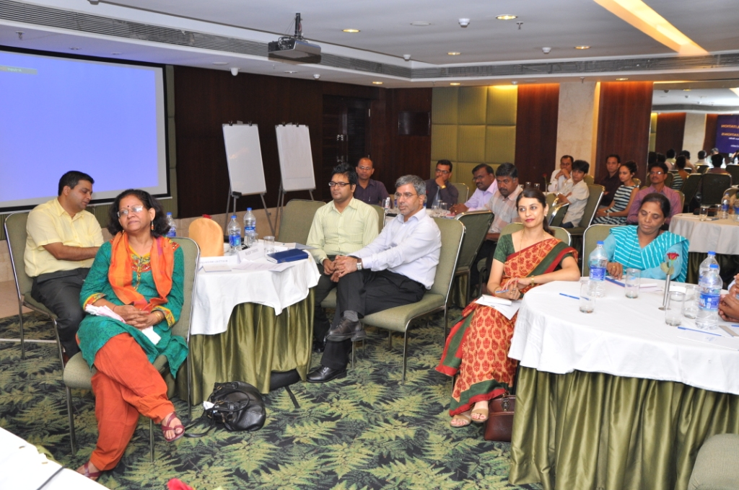
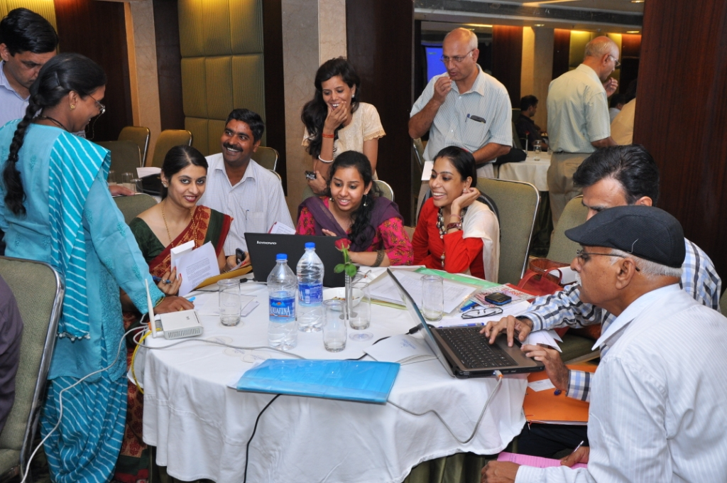
ANNEXURE II – AGENDA
DAVP Empanelment Facilitation Workshop for Community Radio Stations
Tuesday 30 July 2013, at Sarovar Portico, Nehru Place, New Delhi
TIME | SESSION | SPEAKERS & DISCUSSANTS
09:30 – 10:00 | Registration of Participants
10:00 – 10:15 | Introduction of Participants
10:15 – 10:25 | Welcome Address | Dr Sanjaya Mishra, Director, CEMCA
10:25 – 10:35 | Overview & Objectives of Workshop | Ms Rukmini Vemraju, Project Director, CCFC Project, CEMCA
10:35 – 10:45 | Keynote Address: Role of MIB and DAVP in Striving towards Sustainability: Issues and Challenges | Ms Supriya Sahu,  Join Secretary,  Ministry of Information & Broadcasting
10:45 – 11:15 | GROUP PHOTO and TEA BREAK
11:15 – 11:30 | Special Address: DAVP Empanelment: Important Advertising Strategy for CR Stations | Mr L Madhu Nag, Director (AV), DAVP
11:30 – 11:45 | Presentation: DAVP Empanelment Process: Important points to remember for Community Radio Stations | Mr Rajiv Rastogi, Campaign Officer (AV), DAVP
11:45 – 12:00 | OWF India’s Strategic Support to Community Radio – Multiple Technology Options | Mr Rajiv Tikoo, Director, One World Foundation
12:00 – 13:00 | Presentation: DAVP Empanelment Procedure Online | Ms Rupica Saxena, Project Associate, CCFC
13:00 – 14:00 | LUNCH BREAK
14:00 – 17:00 | Hands On Session: DAVP Empanelment Online Form Filling | Ms Rupica Saxena & Ms Poonam Shrivastava, Project Associates, CCFC , with support from Interns
17:00 – 17:15 | Vote of Thanks & Group Photo | Ms Jayalakshmi Chittoor, Senior Consultant, CCFC
17:15 | TEA and CLOSE

