REPORT
Regional Workshop on Information and Communication Technology (ICT) Leadership in Higher Education (11-12 December, 2015, Dhaka)
PREAMBLE
Regional Workshop on ICT leadership in Higher Education 2014, hosted by Bangladesh Open University under the auspices of Commonwealth Educational Media centre for Asia (CEMCA), the educational media organ of the Commonwealth of Learning, Canada from 11-12 December in Dhaka, Bangladesh. The workshop was attended by Vice-Chancellors of public universities, policy makers from the Ministry of Education of the Government of the People’s Republic of Bangladesh and University Grants Commission of Bangladesh as well as Vice-Chancellors /Policy makers from USA and India. The objectives of the workshop were: 1) to provide a platform for Institutional leaders to discuss issues related to use of ICTs in teaching and learning in higher education 2) to sensitize leaders/policy makers about the use and integration of ICT in higher education and 3) to assist the participant leaders to develop strategic plan and roadmap for ICT application in all activities of the university.
Over two days, the attendees listened to keynote speeches, presentations and participated in workshop discussions and group sessions, all around the main theme of ‘ICT Leadership in Higher Education’. The participants were also treated to Bangladeshi cultural performances and Bangladesh Open university Bangladeshi hospitality.
The workshop was completed in 5 sessions. The sessions were: 1) Inaugural Session 2) Session 2- ICT in Higher Education: Policy Perspectives 3) Session 3- Creating Environment for Sharing Educational and Research Resources 4) Session 4- Developing Institutional Strategic Plan for Open, Distance & E-learning 5) Concluding Session.
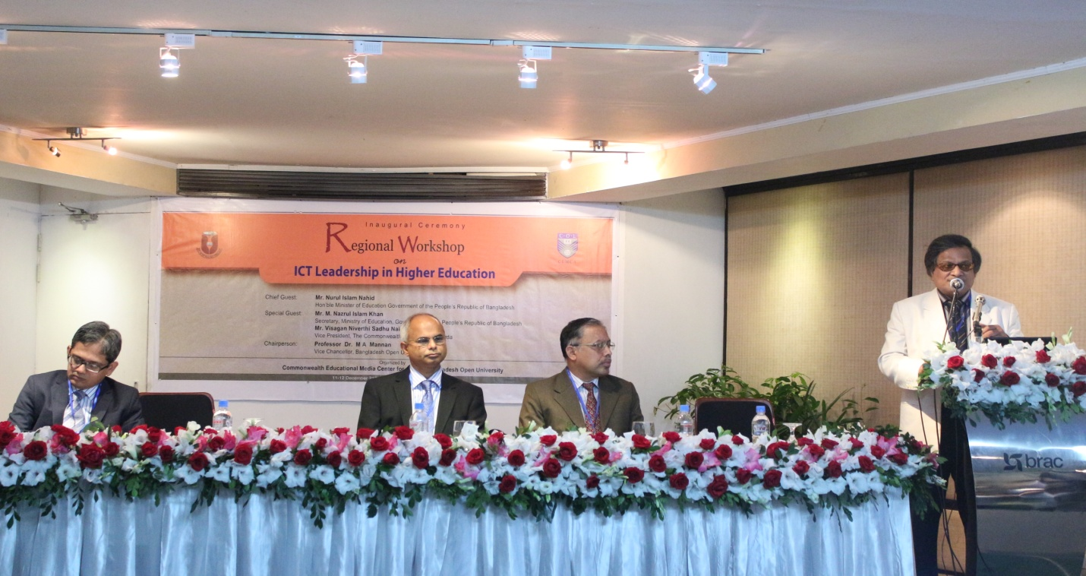

INAUGURAL SESSION
The inaugural session was chaired by Professor Dr. M A Mannan, Hon’ble Vice-Chancellor, Bangladesh Open University while Dr. Sanjaya Mishra, Director, Commonwealth Educational Media Centre for Asia briefed aims and objectives of the workshop. Mr. M. Nazrul Islam Khan, Hon’ble Secretary, Ministry of Education, Government of the People’s Republic of Bangladesh was the chief guest. Mr. Visagan Niverthi Sadhu Naidoo, Vice President of the Commonwealth of Learning became unable to attend the event. However, he has kindly sent a video of his speech on “Drivers for Change in Higher Education’ and this was delivered to the participants.
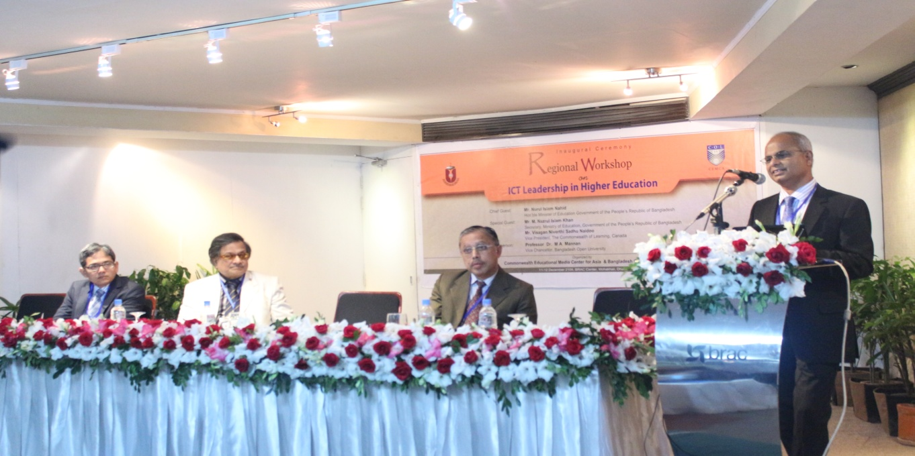
Local Participants
Universities
- Professor Dr. Khaleda Ekram, Vice Chancellor, Bangladesh University of Engineering and Technology
- Professor Dr. Farzana Islam, Vice Chancellor, Jahangirnagar University
- Professor Dr. Fahima Aziz, Vice Chancellor, Asian University for Women
- Professor Dr. Nasreen Ahmad, Pro-Vice Chancellor, University of Dhaka
- Professor Dr. Mohammed Alauddin, Vice Chancellor, Dhaka University of Engineering and Technology
- Professor Dr. Md. Mahbubar Rahman, Vice Chancellor, Bangabandhu Sheikh Mujibur Rahman Agricultural University
- Professor Md. Anwarul Azim Arif, Vice Chancellor, University of Chittagong
- Professor Dr. Md. Alauddin, Vice Chancellor, Mawlana Bhashani Science & Technology University
- Prof. Dr. Harunor Rashid Khan, Vice Chancellor, University of Barisal
- Prof. Dr Muhammad Mizanuddin, Vice Chancellor, University of Rajshahi
- Professor Dr. Mohammad Fayek Uzzaman, Vice Chancellor, Khulna University
- Professor Dr. Md. Rafiqul Hoque, Vice Chancellor, Bangladesh Agricultural University
- Prof. Dr. Al-Nakib Chowdhury, Vice Chancellor, Pabna University of Science & Technology
- Professor Dr. Mohit Ul Alam, Vice Chancellor, Jatiya Kabi Kazi Nazrul Islam University
- Professor Dr. M A Mannan, Vice Chancellor, Bangladesh Open University
- Professor Dr. Md. Jahangir Alam, Vice Chancellor, Chittagong University of Engineering & Technology
- Professor Dr. Muhammed Alamgir, Vice Chancellor, Khulna University of Engineering and Technology
- Maj Gen Sheikh Mamun Khaled, SUP, psc, Vice Chancellor, Bangladesh University of Professionals
- Professor Dr. Knondoker Mokaddem hossain, Pro-Vice Chamcellor, Bangladesh Open University
- Professor Dr.Md. Abu Taher, Treasurer, Bangladesh Open University

University Grants Commission of Bangladesh

- Professor Dr. Mohammad Mohabbat Khan, Member, University Grants Commission of Bangladesh
- Professor Dr. Md. Akhtar Hossain, Member, University Grants Commission of Bangladesh

Ministry of Education

- Mr. M. Nazrul Islam Khan, Secretary,Ministry of Education, Govt. of the People’s Republic of Bangladesh
- Mr. Md. Helal Uddin, Additional Secretary, Ministry of Education, Govt. of the People’s Republic of Bangladesh
- Ms. Zikrur Reza Khanam, Joint Secretary (University), Ministry of Education, Govt. of the People’s Republic of Bangladesh
- Ms. Laila Arzumand Banu, Deputy Secretary, Ministry of Education, Govt. of the People’s Republic of Bangladesh

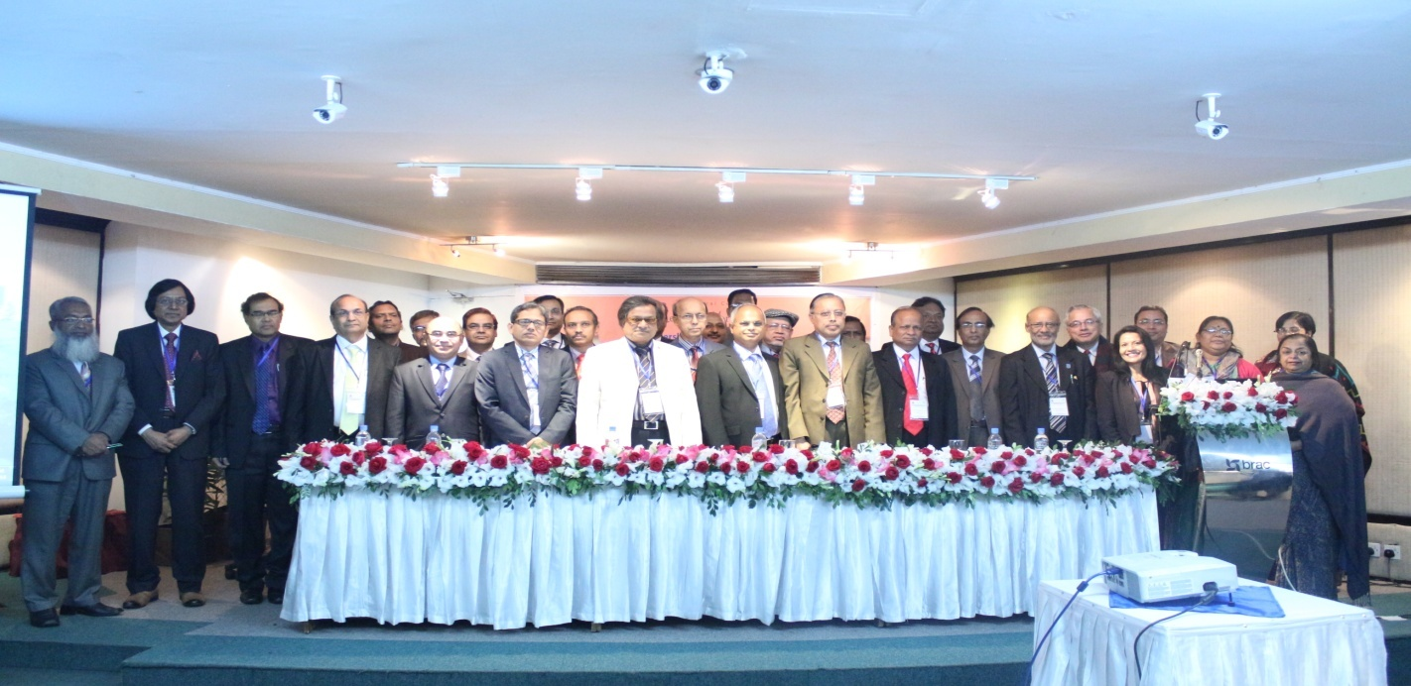

Foreign Participants
- Professor Dr. Rash Bihari Prasad Singh,Vice Chancellor, Nalanda Open University, Bihar, India
- Professor Dr. Manikrao Salunkhe, Vice Chancellor, Yashwantrao Chavan Maharashtra Open University
- Mr. Rajat Baran Mahanta, Registrar, Krishna Kanta Handique State Open University
- Dr. Subhash Chander, Assistant Professor, Lady Irwin College, University of Delhi
- Professor Dr. Praveen Jain, Director, M.P. Bhoj Open University

SESSION TWO- ICT in Higher Education: Policy Perspectives
The 2nd session of the Regional Workshop on ICT Leadership in Higher Education had two speakers. First speaker Professor Faruque Ahmed, e-Learning Specialist, Access to Information Programme, Prime Minister’s Office spoke on ‘Paradigm Shift and Our Universities’. He discussed the issues of how to raise the rank of our universities. He also indicated education gap between Bangladesh universities and world-class universities. He described the status of e-Governance and m-Governance in Bangladesh. He emphasized on to focus on 3rd generation curriculum, industry-academic linkage, faculty development, available educational resources, e-learning platform, and to maintain performance management system. He concluded that “students’ demand cannot be met at the present physical structures and so, we need to adopt ICT in education”.
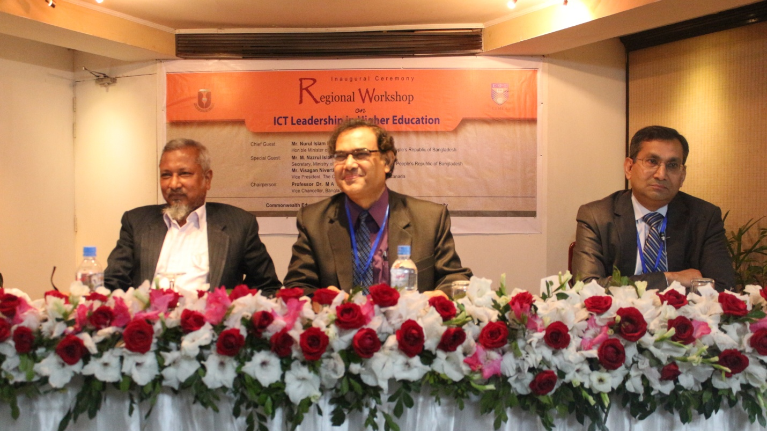
The 2nd speaker Professor Dr. Badrul Huda Khan, President and Founder, McWeaden Education, USA presented a keynote paper on ‘Developing e-Learning Strategies in Universities of Bangladesh’. He discussed the uses of e-Learning. He raised questions about how universities and University Grants Commission should work for development of e-Learning. He made interactions among the participants raising problem issues on ‘how teachers should give spaces for learners from the shifting position of sage of the stage to the position of a guide’. He presented his octagonal model for meaningful e-Learning. He added a motto that information you push, instruction you pull. Students are the boss and teachers are the guides. He concluded with the following recommendations:

- UGC should have a national guideline.
- Education leaders should think locally to do globally.
- Adaptive assessment should be taken.
- Higher education leaders should customize the management of each university as per its own perspective.
- Leaders should follow international standards for education management.

Session 3- Creating Environment for Sharing Educational and Research Resources

The session was chaired by Professor Dr. Mohammad Mohabbat Khan, Member, University Grants Commission of Bangladesh. Firstly, Dr. Sanjoy Mishra, Director, Commonwealth Educational Media Centre for Asia presented a paper of Professor V.Venkaiah, Vice Chancellor, Krishna University on ‘Creating Environment for Sharing Educational and Research Resource’. The key issues of the paper are: Changing university’s research and teaching roles; emerging trends in OERs and role of Open Access in International Development Agencies, addressing the issues of creating an enabling environment and policies for development and sharing of quality educational and research resources.

In addition to that, Dr. Mishra explained the importance of Open Access (OA) and Open Educational Resource (OER) for raising the height of universities. He also mentioned about awareness and use of OER and bridging digital divide by developing infrastructure. Then he conducted a group session through 4 (four) groups. After threadbare discussion among the groups, the following suggestions were noted:

Institutional OER Policy Template

- There should be a policy template for the regulatory authority;
- There should be a model of contract that the institution may enter into contract with an author, artist or creator;
- In the event of any contradiction between policy adopted and the Act / Regulations that governs the institution, the Act / Regulations shall prevail;
- Legal device should be taken regarding institutional OER policy jurisdiction.

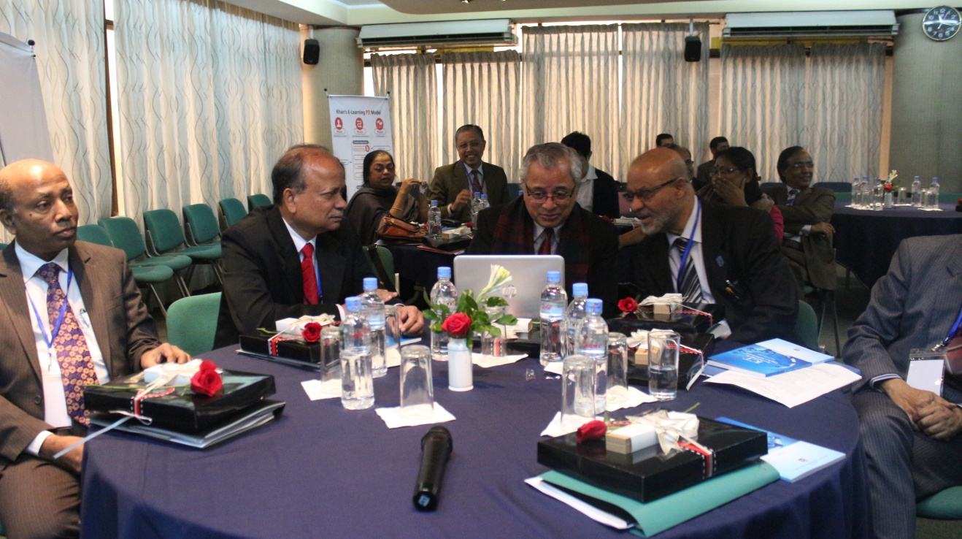

Developing e-Learning Strategy using Badrul Khan’s framework

- Designing teaching & learning strategy;
- Needs of the society-baseline survey;
- Categorize the groups as the specific demand needs;
- Define the different target groups;
- Design and developing appropriate curriculum based on specific target groups;
- Implementation strategy for achieving goals;
- Design and development of assessment strategies;
- Evaluation of the course/program;

- Developing upgraded software;
- Upgrading materials as per social changes of needs.
- Using open resources and media mix
- Materials should be visible and easy to grasp (user friendly);
- Needs to ensure uninterrupted network facilities and strong bandwidth;
- Learner support system- learners must be informed on real-time basis;
- Management system must be compatible with the teaching learning strategies;
- Mindset shift of the administration toward e-learning.

Role of UGC in Spreading E-learning

- Under the guidance of UGC, each public university should have a separate unit for e learning.
- A portion of the syllabus should be introduced in final mode;
- Rigorous monitoring of online curriculum/ pedagogical materials at the user ends;
- Framing policy for identifying fake online journals as to prevent proliferation of plagiarism;
- Government should allocate adequate fund for procuring materials i.e. books, journals;
- UGC should help uninterrupted supply of power.

Session Four- Developing Institutional Plan for Open, Distance & E-learning

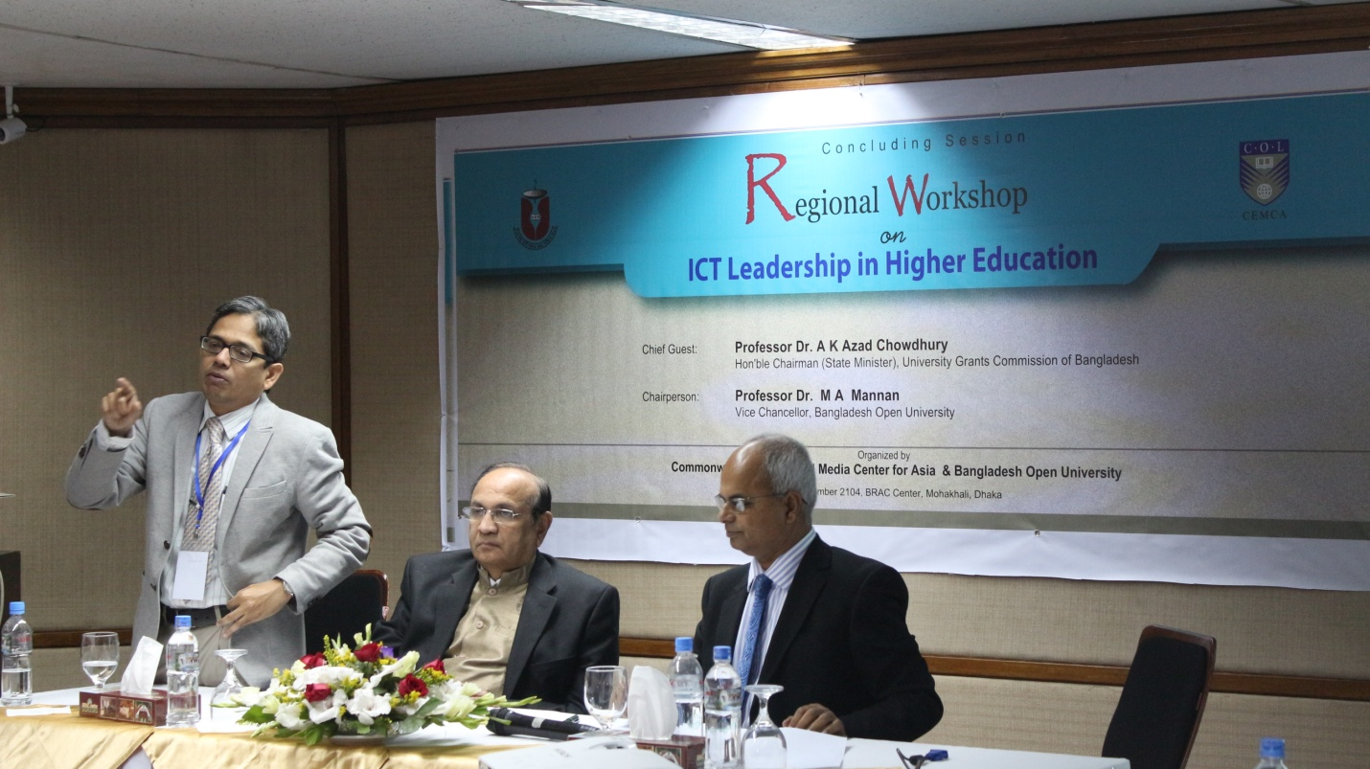

On Friday 12 December 2014 day, the session took place on “Developing Institutional Plan for Open, Distance & E-Learning’ where Dr. Sanjoy Mishra emphasized the use of eLearning at the institution, strategic goals, specific activities, responsibilities for implementation and monitoring, estimated cost/budget, needs of our students, access to programmes across multiple campuses, quality of teaching and learning, preparation our students for the requirements of business and industry, accommodate the different learning styles of students. The session was initially chaired by Professor Dr. Manikrao Salunkhe, Vice Chancellor, Yashwantrao Chavan Maharashtra Open University. Later on, Mr. M. Nazrul Islam Khan, Secretary, Ministry of Education, Government of the People’s Republic of Bangladesh joined as the chair to facilitate the session. In the group-work session, several groups worked on the topic, developing institutional strategic plan for Open, Distance & e-Learning and a few suggestions and comments yielded from group works such as:

- We should ensure Quality Assurance from the beginning of an institution and for these targets; we need to budgets, technological support, and efficient technical staff.

- The modes of teaching should be face to face, blended and online. We need to have pedagogical innovation at 50% courses into online/blended. Internet facilities should be available in the campus. Connectivity’s with online resources would be available.

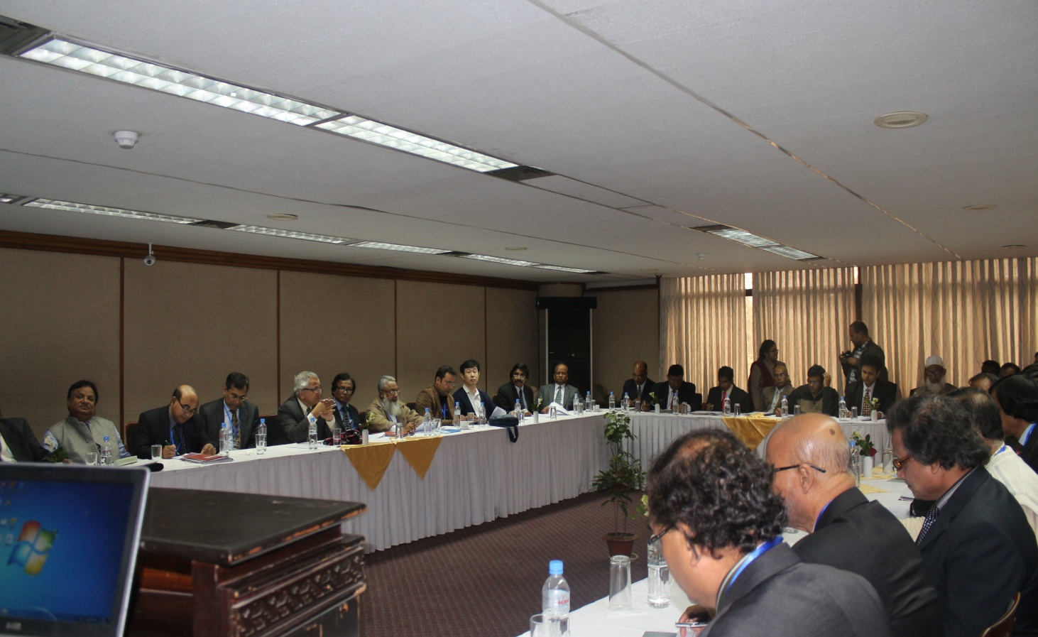

The concluding session was chaired by Professor Dr. M A Mannan, Vice Chancellor, Bangladesh Open University. The Chief Guest of the session was Professor Dr. A K Azad Chowdhury, Hon’ble State Minister and Chairman of University Grants Commission of Bangladesh. Dr. Mishra reflected on the two days workshop and presented the outcomes of the workshop in order to implement ICT in teaching and learning of higher education in the universities of Bangladesh and India.

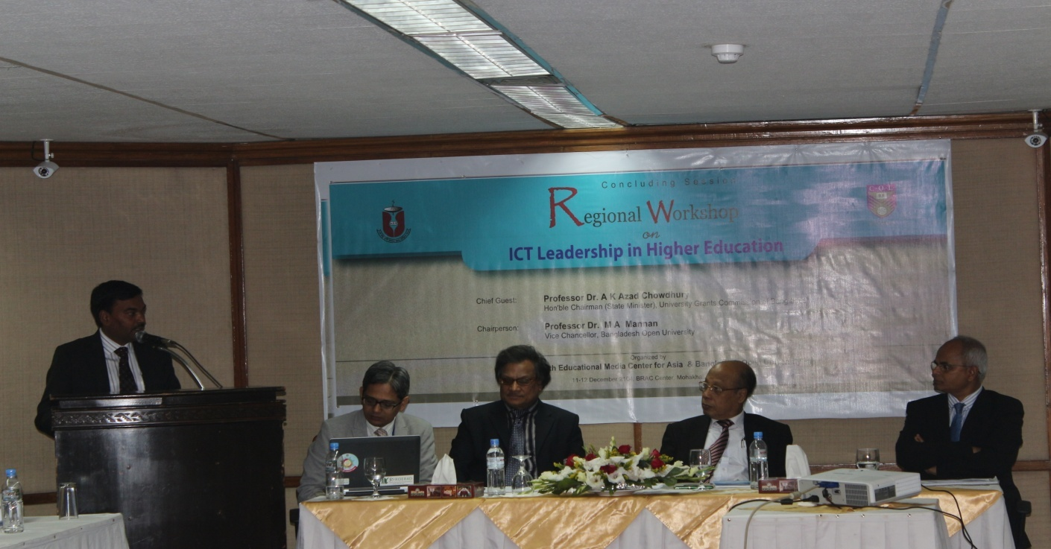

The workshop report was presented by Dr. Md. Shafiqul Alam, Joint Director (Training &Research) of Bangladesh Open University. Finally, Professor M A Mannan, Vice-Chancellor of Bangladesh Open University summarized the recommendations and presented implementation strategies of using ICT in higher education in Bangladesh. The workshop was ended with concluding remarks and vote of thanks by Professor Dr. Mokadddem Hossian, Pro-Vice Chancellor of Bangladesh Open University.

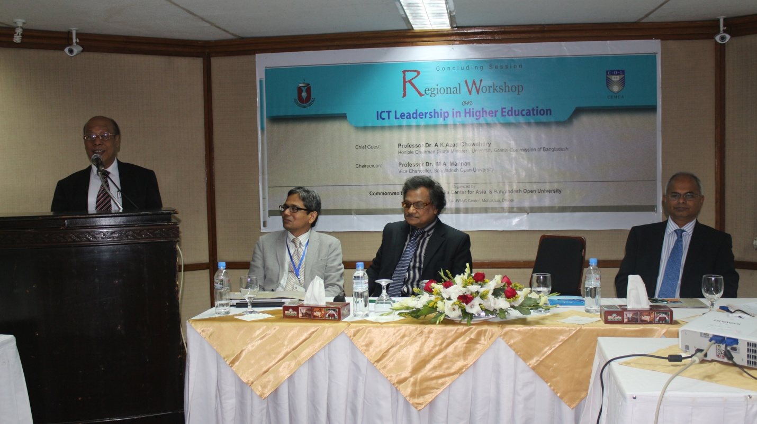

OUTCOMES
Regional Workshop on ICT Leadership in Higher Education 2014 is successfully completed in terms of its organization, active participation of the local and foreign Vice-Chancellors/Policy makers, expected outcomes and sensitization of educational leaders and policy makers in use and integration of ICT in higher education.
The workshop is ended with four main decisions as mentioned below:

- Implement training on e-learning for academics and officers related to use and integration of ICT in education of conventional universities in Bangladesh.

- Formulate a national policy for ICT integration in higher education.

- Formulate an OER policy for Bangladesh

- Develop an e-learning platform for all public universities.

CONCLUSION
This workshop would be a milestone initiative in use of ICT in higher education in Bangladesh. Bangladesh Open University will follow up the decisions taken in the workshop and will be acted as a coordination point with a leading role for implementation of these decisions. BOU with the active assistance of COL/CEMCA will move forward to implement the decisions of the workshop.

(Acknowledgement: On behalf of Bangladesh Open University and all workshop participants (Vice Chancellors/Policy makers), we would like to extend our gratitude and thanks to COL/CEMCA and Dr Sanjaya Mishra, Director of CEMCA for providing all support and cooperation for holding this workshop.)

Relevant Information of the workshop

VENUE OF THE WORKSHOP
BRAC Center, 75 Mohakhali, Dhaka 1212, Bangladesh Tel: 880 2 9886581-82, Fax: 880 2 9886683, Cell: 01787680851, Email: nasim@bracservicesltd.com

ACCOMMODATION
The accommodation for workshop participants (national and international) has been arranged at Summer Palace Hotel, 35 Suhrawardy Avenue, Baridhara Model Town, Dhaka-1212, Bangladesh, Tel: 880 2 8816722/98916722, Fax: 880 2 9890868, Cell: 01817035292, Email: info@summerpalacehotel.com, Web: www.summerpalacehotel.com

OVERALL MANAGEMENT
BOU Team

Advisory Committee
Professor Dr M A Mannan, Vice Chancellor
Professor Dr. Khondoker Mokaddem Hossain, Pro-Vic Chancellor
Professor Dr. Professor Abu Taher, Treasurer
Professor Dr. Abul Hossain Ahmed Buiyan, Registrar

Workshop Organizing Committee

Professor Dr. Sadia Afroze Sultana, Dean, Open School, BOU
Professor Mostafa Azad Kamal, School of Business, BOU
Dr. Md. Shafiqul Alam, Joint Director (Training & Research)
Mr. A. K. M. Iftekhar Khalid, Deputy Director (Training)

CEMCA Team

Dr. Sanjaya Mishra, Director
Mr. R. Thyagarajan, Head, Administration and Finance
Dr. Ankuran Dutta, Program Officer
Dr. Manas Ranjan Panigrahi, Program Officer
Ms. Monica Sharma, Administrative Assistant

CHIEF PATRON

Professor Dr M A Mannan
Vice Chancellor
Bangladesh Open University
Gazipur 1705, Bangladesh
email: drmannan1950@gmail.com; cell number: 01755593377,
Fax: 02 9291122

CONTACT POINT

Dr. Md. Shafiqul Alam
Joint Director (Training & Research)
Bangladesh Open University, Gazipur 1705, Bangladesh
Tel: 880 2 9291151, Fax: 880 2 9291151, Cell: 01754459902
Email: shafiqul_bou@yahoo.com

Mr. A. K. M. Iftekhar Khalid
Deputy Director (Training)
Bangladesh Open University, Gazipur 1705, Bangladesh
Tel: 880 2 9291151, Fax: 880 2 9291151, Cell: 01717179646, Email: khalidfac@yahoo.com

