**OER-based eLearning online facilitation and assessment workshop**



**Organised by:**

 

**CEMCA and WOU**

**On**

**14-16 October 2014**

**At**

**Wawasan Open University**

**Penang, Malaysia**

**Introduction**

Commonwealth Educational Media Centre for Asia (CEMCA) along with Wawasan Open University (WOU) developed and tried out a course on ‘OER based e-Learning’ during 2013-14 as a by-product of developing institutional capacity in WOU in this area. Over 20 academic and academic support staff of WOU in addition to a few participants from other countries got oriented to OER and its use for e-learning through this project. The five modules of the course underwent a trial run during the months of April to July 2014 and the final set of modules is available as OER under CC BY SA for common use.

Wawasan Open University has decided to reuse these modules to develop a Course on ‘OER Integration in an eLearning Environment’ aimed at training educators including teachers and trainers in a F2F, on-line or a blended teaching-learning environment. This is proposed to be one of the initial set of courses to be run by WOU under its reactivated Professional Development and Continuing Education Programme (WOU-PACE). The transactional mode of the courses may vary from entirely F2F to entirely online or a blended mode in accord with the needs of the course curriculum, the target audience and available ICT infrastructure and connectivity. Massive Open Online Courses (MOOCs) with or without support from facilitators with a fee for learner support and certification is also being considered. It is envisaged that PACE will have its own Moodle platform (Wawasan4CPD) to support all PACE courses as needed.

**Expected Learning Outcomes** **of the Programme**

After completion of all the five modules, the participants will be able to:

1. Demonstrate understanding of OER and argue in support of the use of OER.
2. Use appropriate open license to release educational materials as OER.
3. Search and evaluate the quality of OER materials used in different contexts.
4. Design appropriate learning experiences for OER-based eLearning.
5. Offer OER-based eLearning courses and programmes using appropriate technologies.

**Workshop Proceedings**

For achieving these learning outcomes, a workshop was held at the WOU Main Campus from 14-16 October 2014, on “OER-based eLearning online facilitation and assessment” and conducted by Dr. Som Naidu from Monash University, Australia. Of the total 22 participants, 19 were from WOU’s academic Schools, Library and the Educational Technology & Publishing (ETP) unit, and three from DISTED College and Universiti Sains Malaysia. The participants also belonged to three groups: facilitators for the CEMCA OER course, academics going through the ODL training modules as well as facilitators from the Action Research project.

*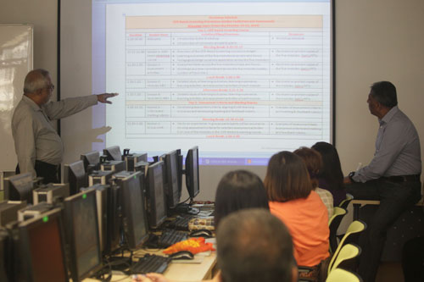  
Deputy Vice Chancellor (Academic-OCL) Prof Mohandas Menon explains the training involved.*

The three-day workshop involved examining the learning outcomes of the five modules of the OER-based eLearning course, developing assessment criteria in line with the learning outcomes, and moderating discussion in an online learning environment. Participants in the workshop explored strategies for supporting students, and how and when to provide feedback to online learners.

This was a hands-on experience and practice in which participants engaged in online role play activities by taking part in simulation exercises for better understanding of online moderation. It involved groups of participants posting comments to issues raised as ‘students’ on WOU’s learning management system (Moodle), while a member moderated the discussion with the student-moderator roles being reversed in a subsequent activity.

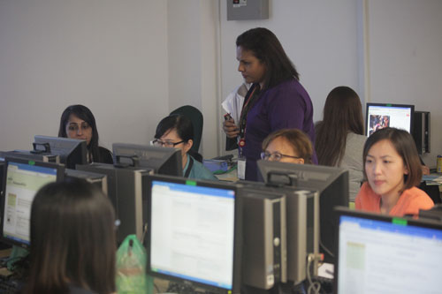  
*Hands-on activity at the Computer Lab.*

According to Dr. Naidu, the three-day workshop was designed to achieve three goals. Firstly, there was the need to orient new staff to the five modules of the OER-based eLearning course that has been developed with the support of CEMCA and WOU over the last 18 months. This course has already been run once with a small number of learners earlier this year on a trial basis and the next step is to scale it up and run it again with larger intakes. In order to serve as tutors and moderators of those modules in subsequent offerings of the course, workshop participants needed to understand the modules.

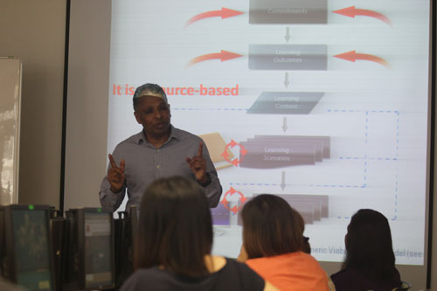

*Dr Som Naidu shares about online moderation.*

Secondly, participants needed to understand a little bit about assessment and providing feedback to learners online. And thirdly, we wanted to upskill participants on providing moderation and facilitation in the online environment. So apart from preparing workshop participants to become moderators and facilitators for the OER-based eLearning course, it also served to prepare them for moderating and facilitating online courses more generally, he added.

**Annex: 1**

|  |  |  |  |
| --- | --- | --- | --- |
| **OER-Based eLearning – Online Facilitation and Assessment Workshop**  **Wawasan Open University (October 14-16, 2014)** | | | |
| **Day 1: OER-based eLearning Course** | | | |
| **Duration** | **Session focus** | **Activities/Plans/Processes** | **Resources** |
| 9.00-09.45 | Welcome | * Introduction to the Workshop * Introduction of conveners and participants | * Workshop schedule |
| **Morning Break: 9.45-10.15** | | | |
| 10.15-11.00 | Session 1: OER-based elearning course | * Overview of the OER-Based eLearning course (coverage) * Learning outcomes of the five modules (overview and focus) * Pedagogical design (examine application across the five modules) | * Electronic or printed copies of the five modules. Som’s PPTs |
| 11.00-1.00 | Session 2: Assessment activities | * Assessment tasks across the five modules (scope and focus) * Workload and time commitment across the five modules (weeks, number of hours etc.). | * Electronic or printed copies of the five modules. Som’s PPTs |
| **Lunch Break: 1.00-2.00** | | | |
| 2.00-3.15 | Session 3: Modules 1&2 | * Detailed study of learning outcomes, learning experience, learning activities, and assessment activities of each module. | * Electronic or printed copies of the modules. Som’s PPTs |
| **Afternoon Break: 3.15-3.30** | | | |
| 3.30-5.00 | Session 4: Modules 3, 4&5 | * Detailed study of learning outcomes, learning experience, learning activities, and assessment activities of each module. | * Electronic or printed copies of the modules. Som’s PPTs |
| **Day 2: Assessment Criteria and Marking Rubrics** | | | |
| 9.00-10.30 | Session 1: Criteria and marking rubrics | * Developing assessment criteria, aligning it with learning outcomes and developing marking and feedback rubrics | * Examples of assessment criteria and marking & feedback rubrics |
| **Morning Break: 10.30-11.00** | | | |
| 11.00-1.00 | Session 2: Group work | * Hands-on experience: In groups participants will be required to develop assessment criteria for selected assessment activities from one of the modules in the OER-Based eLearning course. | * Examples of assessment tasks, assessment criteria and marking and feedback rubrics |
| **Lunch Break: 1.00-2.00** | | | |
| 2.00-3.15 | Session 3: eModeration | * Participants will be divided into 5 groups (with one of the members assigned a tutorial role) and asked to engage in the discussion of one activity from one of the Modules. | * eModerating guidelines * OER-Based eLearning Modules |
| 3.30-5.00 | Session 4: eModeration | * Participants will be divided into 5 groups (with a *different member* assigned a tutorial role) and asked to engage in the discussion of one activity *from a different Module*. | * eModerating guidelines * OER-Based eLearning Modules |
| **Day 3: MOOCs and eModeration** | | | |
| 9.00-10.30 | Session 1: eModeration | * Participants will be divided into 5 groups (with a *different member* assigned a tutorial role) and asked to engage in the discussion of one activity *from a different Module*. | * eModerating guidelines * OER-Based eLearning Modules |
| **Morning Break: 10.30-11.00** | | | |
| 11.00-1.00 | Session 2: eModeration | * Participants will be divided into 5 groups (with a *different member* assigned a tutorial role) and asked to engage in the discussion of one activity *from a different Module*. | * eModerating guidelines * OER-Based eLearning Modules |
| **Lunch Break: 1.00-2.00** | | | |
| 2.00-3.15 | Session 3: eModeration | * Participants will be divided into 5 groups (with a *different member* assigned a tutorial role) and asked to engage in the discussion of one activity *from a different Module*. | * eModerating guidelines * OER-Based eLearning Modules |
| **Afternoon Break: 3.15-3.30** | | | |
| 3.30-5.00 | Session 4: Debrief | * Group discussion of issues and challenges? | * eModerating guidelines * OER-Based eLearning Modules |

**Annex: 2**

**Workshop on ‘OER Based eLearning- Online Facilitation and Assessment’ 14-16 October 2014**

|  |  |  |
| --- | --- | --- |
| **Sl.No** | **Name of the Participants** | **School** |
| 1 | Azrina P. Jamal Mydin | SST |
| 2 | Chandarasekaran | SST |
| 3 | Ooi Wen Hui | SST |
| 4 | Tan Choo Jun | SST |
| 5 | Ms. Rosalie Tan | SBA |
| 6 | Farzanah Ali Hassan | LLS |
| 7 | Norhasni Abdul Aziz | LLS |
| 8 | Dr. Goh | SELC |
| 9 | Ong Theng Theng | SELC |
| 10 | Arathai Din Eak | SELC |
| 11 | Jasmine | SLFS |
| 12 | Deehbanjali | SBA |
| 13 | Vighna | SELC |
| 14 | Ooi Chia-Yi | SFLS |
| 15 | Prakash | SBA |
| 16 | Marnisya Rahim | ETP |
| 17 | Chng Lay Kee | ETP |
| 18 | Koh Kah Ling | ETP |
| 19 | Ravindran Raman | SBA |
| 20 | Ms Chin Sook Fui | Tutor |
| 21 | Dr. Malini Ganapathy | Tutor |
| 22 | Tan Siew Gaik | Disted |
| 23 | Mohan Menon |  |
| 24 | Phalachandra |  |
|  |  |  |