|  |  |  |
| --- | --- | --- |
|  | **Workshop on ICT Integrated Teacher Education for DIET Teacher Educators of Madhya Pradesh** | http://jobsrock.in/wp-content/uploads/2014/04/NCERT-delhi-logo.png |

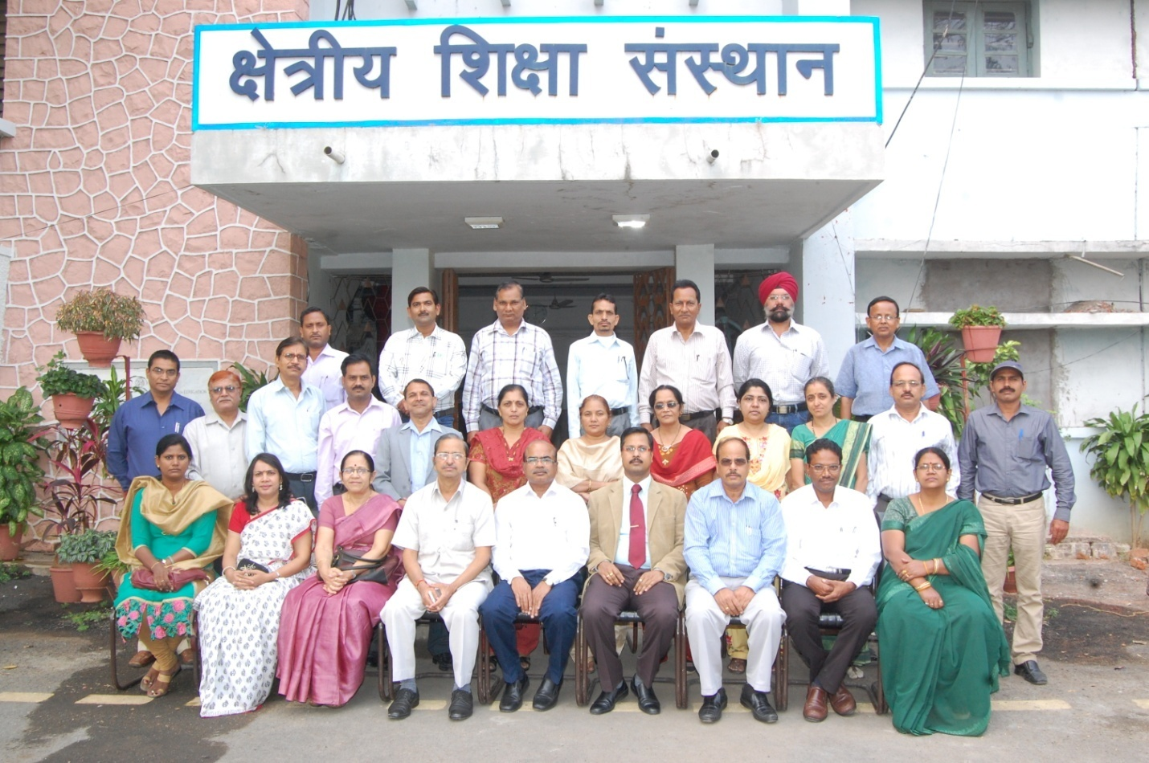

**15-17 November 2014**

***Organised by***

**Commonwealth Educational Media Centre for Asia (CEMCA), New Delhi**

***In collaboration with***

**Regional Institute of Education, Bhopal, Madhya Pradesh**

**(A Constituent Unit of National Council of Educational Research and Training, New Delhi)**

**INTRODUCTION**

Knowledge, education and learning are strongly linked with society and its evolution. One cannot teach or learn now-a-days the same way as a century ago. The IT (information technology) and internet communications revolutions of the past two decades have transformed teaching-learning norms and systems around the world—particularly in post-industrial societies of the first world—beyond recognition. With the introduction of ICT (instructional communication technologies) into classrooms of progressive schools worldwide, it is now possible to supplement and enrich chalk-n-talk and textbook teaching with live multi-media presentations on smart boards, to facilitate deeper understanding of curricular concepts and subjects. Moreover, the internet revolution has created a vast universal digital library accessible to all, enabling students to reach the world’s best teachers with the click of a mouse.

More particularly, the quick and deep changes brought by ICT (Information and Communication Technologies) have a strong influence on knowledge, teaching, learning. But pupils themselves are changing and evolving decade after decade. And, education must permanently adapt to the new generations of pupils. In terms of information, communication, computers, and technology, youngsters have new abilities, new approaches, and new concepts. Certainly education has to take this into account, particularly, at a time when pupils seem to be more competent than teachers in technological abilities! But the new generation of today and tomorrow cannot be described only through technology. We have to take into account other parameters.

Technology is now available for new forms of learning. But a huge effort must be made concerning pedagogy. The gap between technology and pedagogy is increasing. The tendency of school systems is just to add new technologies to traditional pedagogy, to adapt traditional courses to some new technological tools, avoiding renewal of the pedagogy, avoiding integration of ICT into education (Interactive electronic blackboards – or white boards – are an interesting example: they put new technologies in the classroom without disturbing the traditional pedagogy, the traditional relationship between the teacher and the pupils). Research and innovation must address and ask pedagogy: how can ICT help enriching pedagogy, changing pedagogy; how can pedagogy really take all the benefits from new technologies.

**Need of Training**

Learning in a digital society brings new challenges to schools, and since pupils will now be digital natives, schools must address these challenges. But, schools are not really prepared, not really ready for digital education! Generally speaking, schools are not connected to networks. The Internet is mostly out of schools, not inside! Nowadays, digital natives use computers, ICT, the Internet mostly out of school. Moreover, there is no evidence that one learns better through ICT. Of course, we all know lots of excellent examples of successes in teaching with computers, with ICT, we all know successful experiments. We know that innovative situations, innovative resources, and innovative tools give good results and develop the pupils’ motivation. But fundamentally, can we prove that pupils are studying better, that ICT are really improving learning? The ‘pedagogical model’ of schools does not fit with ICT: the traditional school pedagogy is mainly based on trans- missive learning, on non-constructivist methods, on individual learning, individual intelligence. In opposite, ICT offer the opportunity of constructivist approaches, collaborative work, collective intelligence, and collective achievement.

Schools must adapt pedagogy to the new pupils and to the new digital tools and resources, new knowledge, new context of networks and of collective intelligence. Schools have to transform their pedagogy, to enrich pedagogy according to the new knowledge, to the networked society, to the collaborative and collective needs of pupils. New technologies are not only to be integrated in the school: they give the opportunity for a real enrichment of pedagogy. Schools have to admit and acknowledge that they are not the only learning place. They have to integrate the new forms of knowledge, the complexity of knowledge, and the new forms of competences. They have to integrate the collective dimension. They have to integrate the world of networks. For instance, when we see how quickly and widely social networks (Facebook, Twitter, etc.) are developing, we must seriously ask the question whether schools should take this into account, integrate such social networks, experiment how one can learn through social networks. And, schools have to mix presence and distance, to manage time and space for learning, to prepare pupils for lifelong e-Learning. Therefore, the teachers must be equipped with the ICT competencies.

In order to equip the teachers with the ICT competencies, our teacher-educators must train the teachers to integrate the content with the pedagogy and the technology. A well-blended technology and pedagogy with the content can provide the opportunity for the learners to have meaningful learning. So, our teacher-educators should be equipped with the skills required for the blended learning. Therefore, there is a need to train the teacher-educators so as to enable them to use ICT and integrate them with contents they teach and pedagogy. The proposed training programme has been conceived mainly in this direction (The workshop schedule is given in Annexure-1).

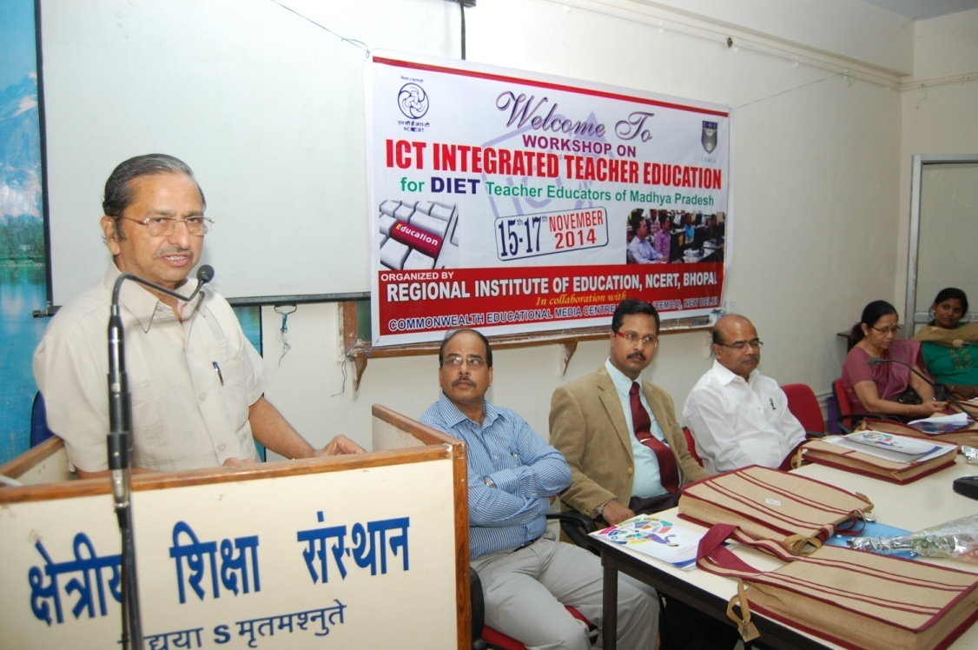

*Dr. O.P.Sharma, Additional Director, RSK, Bhopal in the Inaugural session*

**Objectives**

The objectives of the training programme are as follows:

1. To create awareness and interest among the Elementary Teacher Educators, i.e. DIET faculties, on the use of ICT in their professional activities.
2. To equip the DIET faculties with the knowledge and skill of integrating the content with pedagogy and ICT.
3. To make the DIET faculties aware of the different resources, including open educational resources, which they can use in developing content-based-materials for the curricular transaction.
4. To encourage the DIET faculties to use Web 2.0 tools for effective teaching learning.
5. To provide hands-on-experience in the use of ICT in learning.
6. To equip the DIET faculties with the techniques of using ICT for student assessment.

**INAUGURAL SESSION**

At the outset, Dr. N.C. Ojha, Asst. Professor, RIE, Bhopal, the co-ordinator of the programme, welcomed all the guests and the participants of the programme. He outlined the need of organizing this prograame for the teacher-educators. He also described the objectives of the prograame. In the inaugural session of the workshop, Sh. O.P. Sharma, Addl. Commissioner, Rajya Shiksha Kendra (RSK), Bhopal, Prof. H.K. Senapaty, Principal, Regional Institute of Education (RIE), Bhopal, Prof. K.K. Khare, Dean of Instruction, RIE, Bhopal, Prof. Reeta Sharma (Retd.), Dr. Manas Ranjan Panigrahi, Programme Officer, CEMCA, Dr. Ratnamala Arya, Associate Professor were present. Sh. Sharma inaugurated the workshop. In his inaugural speech he stressed on the need of imparting training to the teacher-educators in the field of ICT. In the today’s technologically advanced world, the teacher-educators have to be adorned with the various ICT skills needed for transacting the contents in the classrooms. Prof. Senapaty, in his speech, outlined the paradigm-shift in the education. He enumerated that NCF-2005 has given importance to the ‘Constructivist’ learning pedagogy over the ‘Behavioural’ pedagogy. In the constructivist learning situation, the learner creates his own knowledge. ICT can play a great role in creating the learning situation. Therefore, there is a need to integrate the technology with the pedagogy and the content. He said that earlier we were learning from the technology. He also explained the TPACK concept of UNESCO. Prof. Kahre stressed on the use of technology in the classroom situation. Dr. Manas Ranjan Panigrahi described the role of CEMCA in the field of teacher education. He also described the importance of ICT in the education. The participants were requested to introduce themselves (The list of the participants is given in Annexure-2). At last, Dr. Ratnamal Arya, Associate Professor, RIE, Bhopal proposed the vote of thanks.

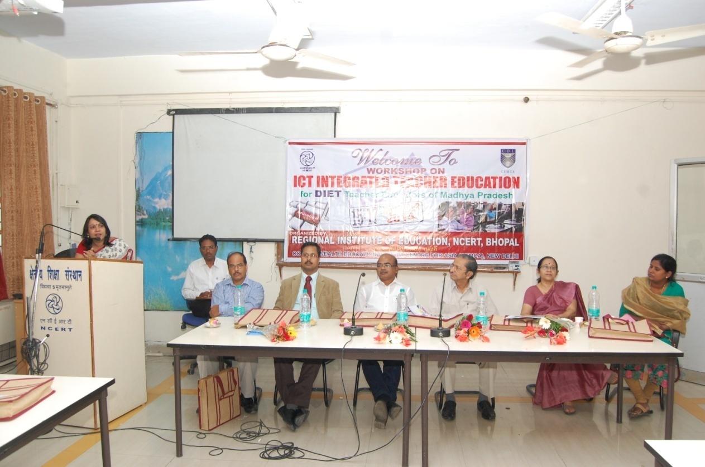

*Inauguration of the 3-Day Workshop*

**DAY- One**

**Session–1: ICT in Education**

The first session of the day was conducted by Dr. Manas Ranjan Panigrahi, Programme Officer, CEMCA. He discussed the role of ICT in education. He discussed the role of teacher in the creation of the knowledge and its dissemination. He briefed the stages of evolution/development of the ICT revolution in the world. In the to-day’s world a teacher feel handicap of without having the knowledge of ICT. He explained the different usage if ICT education and how it helps a teacher-educator to train the future teacher of the nation. He described, through a PPT presentation the UNESCO-ICT Competency Framework for the Teachers. It is framework that outlines the competencies needed for the teachers to integrate ICT in the content with the pedagogy. He emphasized that the ICT can play a major role in the following areas of education for the growth and acquisition of knowledge:

1. Understanding ICT in education
2. Curriculum and assessment
3. Pedagogy
4. ICT
5. Organisation and administration
6. Teachers’ professional development

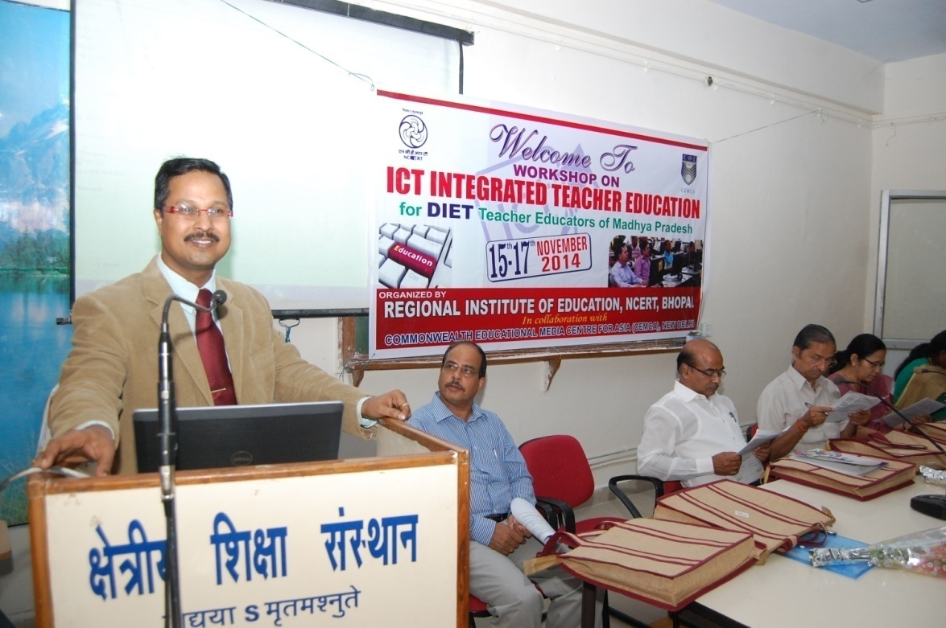

*Dr. Manas Ranjan Panigrahi of CEMCA in the Inaugural Session*

The three growth phases of knowledge acquisition are

1. Technology literacy
2. Knowledge deepening
3. Knowledge creation

ICT Competency Framework for the Teachers can be used to support the professional development for

1. Teacher-educators (both pre-service and in-service training)
2. Teachers (both pre-service and in-service training)
3. Educational staff working in the area of ICT in education

Dr Manas Ranjan Panigrahi also highlighted the different usage of ICT in education in general and teacher-education in particular.

**Session–2: Interactivity, Synchronous and Asynchronous Technologies;   
 Online Tools for Teaching Learning**

Dr. G. Mythili of Indira Gandhi Open University (IGNOU), New Delhi, introduced the participants with the various synchronous and asynchronous tools of ICT which are available on-line. She also explained the some of the tools of this variety and demonstrated on-line.

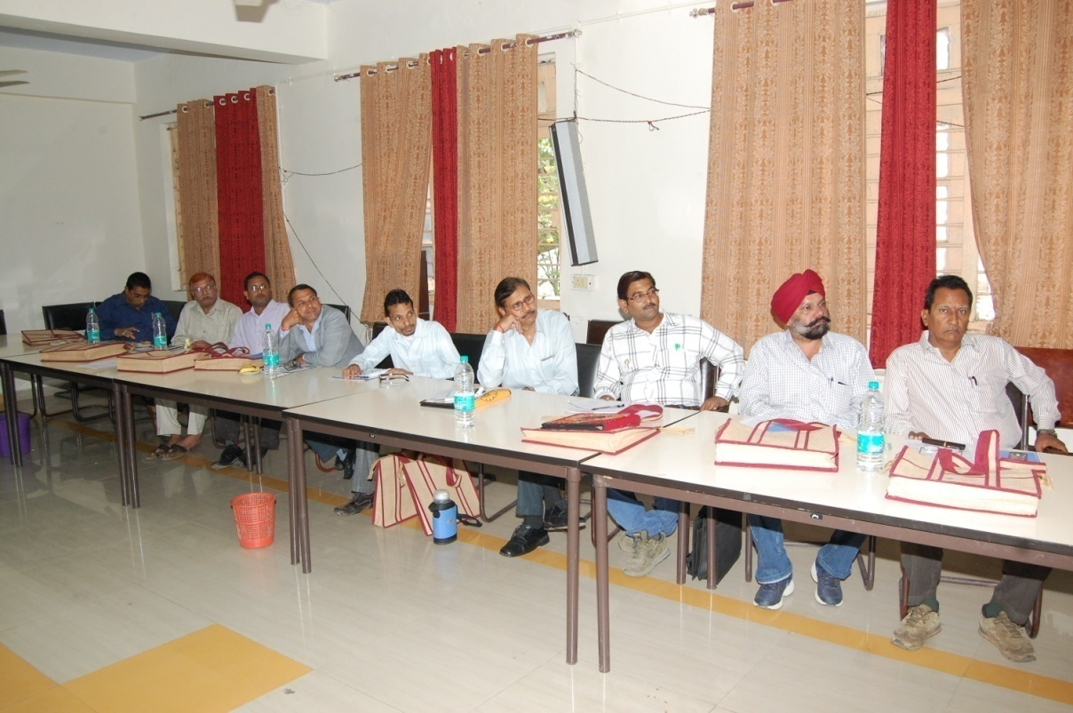

*Participants attending the Technical Session*

**Synchronous Tools**

1. MSN
2. Google talk
3. Yahoo messenger
4. Video messenger
5. Skype

**Asynchronous Tools**

1. Blogs
2. Wikis
3. E-mail
4. Podcasting
5. Newsgroups
6. YouTube
7. On-line forums
8. Audiographics

**Social Networking**

1. Twitter
2. Facebook
3. YouTube
4. Flicker
5. Pinterest
6. Instagram

**Course Management**

1. Learning management system (LMS)/Content management system (CMS) : Moodle
2. Joomla
3. Sakai, etc.

**Knowledgebase**

1. Online encyclopaedia
2. Online journal
3. Online magazines
4. Online libraries

**Computing Tools**

1. Word processors
2. Spreadsheets
3. Presentation software
4. Database maintenance

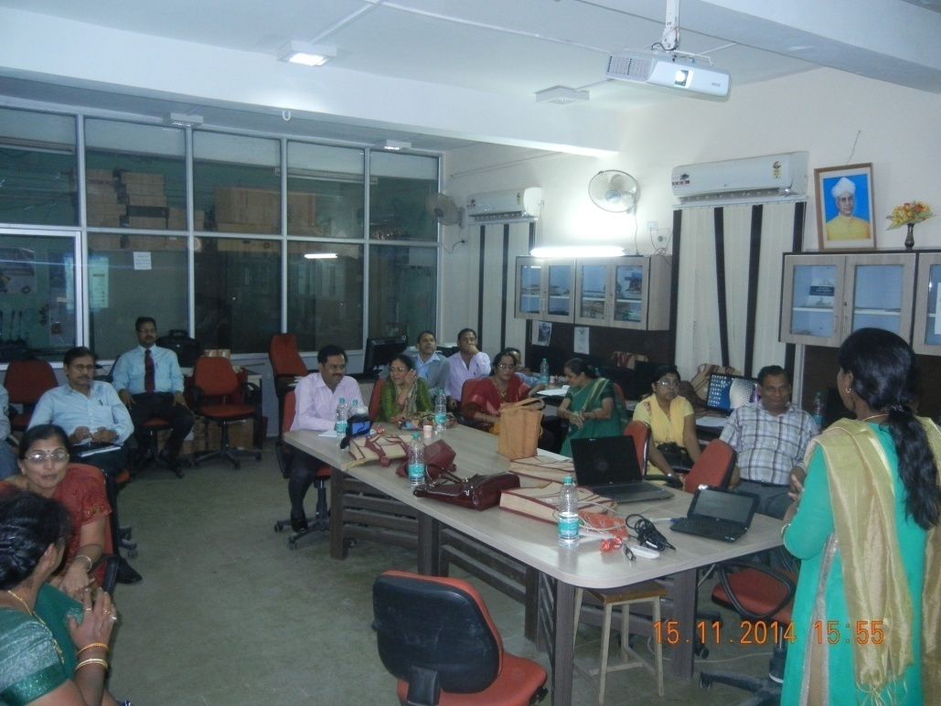

*Dr. G.Mythili, IGNOU facilitating the Hands-on-Practice*

**Hands-on Practice: Working collaboratively in Group using Synchronous   
 and Asynchronous Technologies**

Dr. G. Mythili, after a theoretical presentation of these synchronous and asynchronous tools of ICT, provided hands-on practices to the participants. Participants enjoyed the practice session. The participants, themselves, practiced the different components of the synchronous and asynchronous technologies.

**Session–3: Understanding Open Educational Resources: Role in Teaching   
 and Learning**

Dr. Manas Ranjan Panigrahi, in this session explained the meaning and concepts of open educational resources and their uses. Open educational resources (OER) are freely accessible, [openly licensed](http://en.wikipedia.org/wiki/Open_license) documents and media that are useful for teaching, learning, and assessing as well as for research purposes. The term OER was, firstly, coined at UNESCO's 2002 Forum on Open Courseware and designates "teaching, learning and research materials in any medium, digital or otherwise, that reside in the public domain or have been released under an open license that permits no-cost access, use, adaptation and redistribution by others with no or limited restrictions.

Open educational resources include full courses, course materials, modules, textbooks, streaming videos, tests, software, and any other tools, materials, or techniques used to support access to knowledge. The [Organization for Economic Co-operation and Development](http://en.wikipedia.org/wiki/Organization_for_Economic_Co-operation_and_Development) (OECD) defines OER as: "digitised materials offered freely and openly for educators, students, and self-learners to use and reuse for teaching, learning, and research. OER includes learning content, software tools to develop, use, and distribute content, and implementation resources such as open licences" (This is the definition cited by Wikipedia's sister project, [Wikiversity](http://en.wikipedia.org/wiki/Wikiversity).). By way of comparison, the [Commonwealth of Learning](http://en.wikipedia.org/wiki/Commonwealth_of_Learning) "has adopted the widest definition of Open Educational Resources (OER) as 'materials offered freely and openly to use and adapt for teaching, learning, development and research'". The [WikiEducator](http://en.wikipedia.org/wiki/WikiEducator) project suggests that OER refers "to educational resources (lesson plans, quizzes, syllabi, instructional modules, simulations, etc.) that are freely available for use, reuse, adaptation, and sharing'

Open educational resources often involve issues relating to [intellectual property](http://en.wikipedia.org/wiki/Intellectual_property) rights. Traditional educational materials, such as textbooks, are protected under conventional [copyright](http://en.wikipedia.org/wiki/Copyright) terms. However, alternative and more flexible licensing options have become available as a result of the work of [Creative Commons](http://en.wikipedia.org/wiki/Creative_Commons), an organization that provides ready-made licensing agreements that are less restrictive than the "all rights reserved" terms of standard international copyright. These new options have become a "critical infrastructure service for the OER movement." Another license, typically used by developers of OER software, is the [GNU General Public License](http://en.wikipedia.org/wiki/GNU_General_Public_License) from the [free and open-source software](http://en.wikipedia.org/wiki/Free_and_open-source_software) (FOSS) community. Open licensing allows uses of the materials that would not be easily permitted under copyright alone.

He described the different types of the open educational resources. These resources include: full courses, course materials, modules, [learning objects](http://en.wikipedia.org/wiki/Learning_object), [open textbooks](http://en.wikipedia.org/wiki/Open_textbook), openly licensed (often streamed) videos, tests, software, and other tools, materials, or techniques used to support access to knowledge. OER may be freely and openly available static resources, dynamic resources which change over time in the course of having knowledge seekers interacting with and updating them (such as this Wikipedia article), or a course or module with a combination of these resources.

**Session–4: CEMCA Community of Practice for Teacher Educators**

This session was facilitated by Dr. Mytili. This session enabled the participants to show how the online technologies work for presentation and collaboration. She deliberated upon pioneering the models of Teacher Education: Teacher Educators Communities of Practice and Open Educational Resources. She said there is a need to make aware of these OER, so that the teacher education can touch to the new heights. She explained the Teacher Educators–Community of Practice (COP) platform.

Free and Open Source Software were explained like Lunar eclipse with Stellarium, Maths with Geogebra, Geography with Marble, Kalzium–Chemistry, Image editing through GIMP, Open Shot Video Editor, Audio editing through audacity, Mindmap–Freemind, etc. She also highlighted the Web platform for teacher educators across India available online at <Http://Teacher-Network.in> and the Teacher education model.

**DAY–Two**

**Session-1: Teacher Activities supported by ICT: Curriculum planning, Instructional design, Content delivery, Student Assessment; recent trends in online education**

This session was taken by Dr. Mythili. She discussed the each and every component of the curriculum planning, instructional design, content delivery, student assessment and the recent trends in online education. She through her PPT discussed in detail the curriculum planning and its needs as well as the steps. She also dealt the various models of the instructional design. By using the ADDIE model of instructional design, she developed a content material. The participants were asked to design a course, based on the ADDIE model. She also discussed at length the ASSURE model. The participants were provided the ample time for hands-on –practices. CMS and LMS were also discussed.

Assessment plays a great role in education. Therefore, it is necessary that the teacher educators must learn the different kinds of assessment and their procedures. She said that there are different ICT tools which are available for the assessment.

In the last part of her session, she discussed the recent trends in on-line education, blended-learning approach, virtual learning, etc.

**Session-2: Using Social Media: Overview on Facebook, Twitter, Google   
 hangouts, You Tube, Photo-sharing**

This session was taken by Dr. Mythili. She, through PPT and also through on-line presentation discussed thoroughly the concepts and the tools related to these social media. Later on, she demonstrated the each of these social media and their uses in the teacher education, in particular, and education, in general. She also demonstrated through examples. Later on the participants were also provided hands-on practices on these components.

**Session-3: Using Wikis and Blogs**

This session was taken by Dr. Mythili. In this session, participant were explained how to create a blog. Then the participants were given hands on practical and participant created their blogs on blogspot.com and Wordpress. They were also introduced to WikiEducator and accounts were created in WikiEducator. The participants made edit in their user pages.

**Session-4: Preparing teaching content: Using Audio/Podcasts/ Video/Vodcasts**

This session was taken by Dr. Mythili. In this session, Participants were introduced to audacity, open source software to create audio content. They were also shown how to create video content with the Window Movie Maker. The participants created podcast and movie samples from still images and added voice to these. The participants practiced these on-line.

**DAY–Three**

**Session-1: Creative Commons Licences**

This session was taken by Dr. Manas Ranjan Panigrahi. There were six types of Common Open Licenses, i.e., CC-BY, CC-BY-SA, CC-BY-NC, CC-BY-NC-SA, CC-BY-ND, and CC-BY-NC-ND. These were explained to the participants. Example were cited for different technology and platform for OREs like Wikipedia, Wikieducator, Wikiversity, Wikispaces, Connexions, MIT Open Course Ware, OLI-CMU, Flexi Learn, Open Learn and PRE Commons. Resources were told from where ORE’s can be searched. Further, the Wiki approach to content development and teaching was informed.

**Session -2: Collaborative practices: Google Docs**

This session was taken by Dr. Myhili. In this Session, cloud computing was explained and how the Google application can be used for the teaching and learning purposes. Google Forms were created and demonstrated on how we can collect data and how this can be used for assessment purpose.

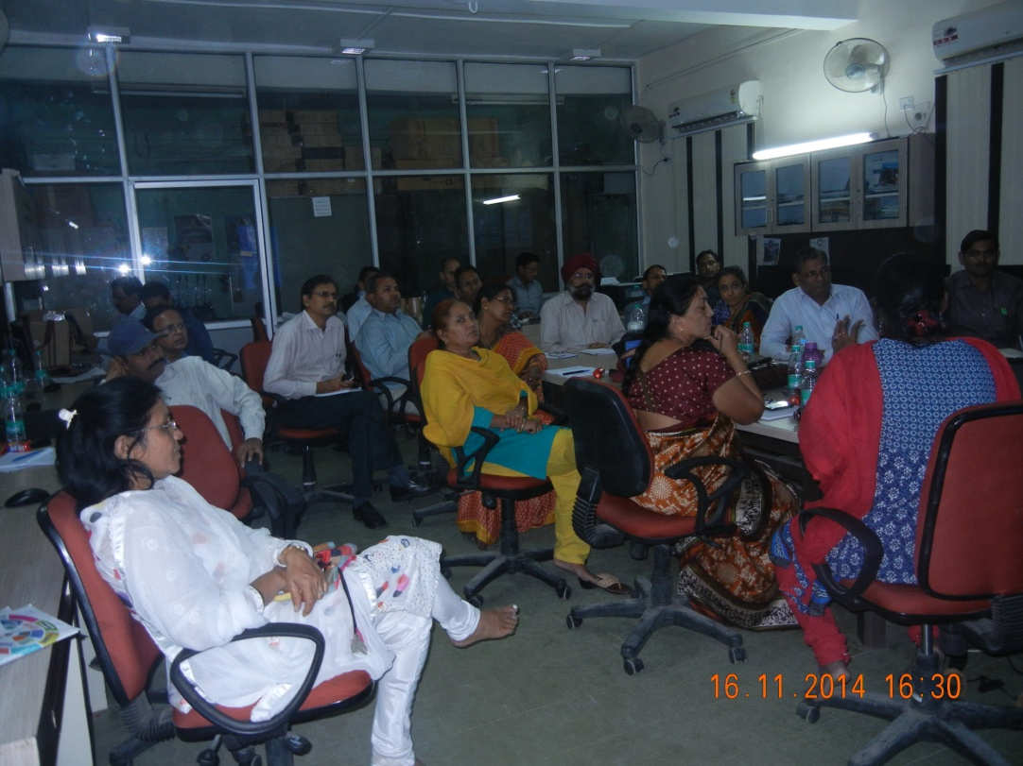

*Participants Watching the Presentations of Dr. G. mythili, IGNOU, New Delhi*

**Session-3: Student Assessment using ICT, including e-Portfolio, creating quizzes (Hot Potato); Refinement of products created by participants as hands on practice**

This session was taken by Dr. Mythili. She, in detail, discussed the computer/ICT-based evaluation and the alternative evaluation practices, like, e-port-folio, rubrics, peer-evaluation, etc. She also demonstrated before the participants, e-rubrics and its development, through on-line, in different subjects. She demonstrated the use of hot potato for the evaluation purposes.

**VALEDICTORY SESSION**

Valedictory ceremony was held at 4.00 pm. Prof. H. K. Senapaty, Principal RIE, Bhopal was the Chief Guest of the ceremony. It was attended by Prof. J. Mandal, as the Guest of Honour.

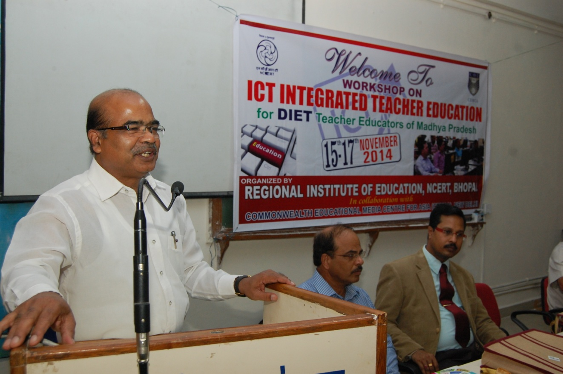

*Prof. H.K.Senapaty, Principal, RIE, Bhopal addressing the Participants*

* **Report by Workshop Coordinator: Dr. N C Ojha, RIE, Bhopal**

Dr. N.C. Ojha, the co-ordinator of the workshop, presented a brief report of the workshop. He expressed that almost all the areas of ICT which are required for a teacher educator were dealt in the workshop. He expressed his satisfaction that the participants even after the 5.30 pm used sit in the laboratory up to 7.30pm and practiced the matter what they received in the day’s session. He also expressed his deep sense of gratitude to CEMCA, for providing opportunity to organize the workshop.

* **Remarks by: Ms. G. Mythili, IGNOU and Dr. Manas Ranjan Panigrahi, Programme Officer Education, CEMCA**

Dr. Mythili expressed her satisfaction over the organization of the workshop. She also expressed her pleasure on the keen interest for learning ICT that the participants had shown in the last three days.

Dr. Manas Ranjan Panigrahi thanks the participants for their active participation in the workshop. On the demand of the participants for the organization of the more workshop of this kind, he also assured that the CEMCA may organize this kind of workshop for the teacher-educators of Madhya Pradesh, in future.

* **Feedback by Participants**

After the completion of the workshop, feedback of the participants was taken, in order to assess effect of the workshop on the different topics covered during the workshop. A questionnaire was developed by the CEMCA for assessing the effect of the workshop. It was distributed to the participants. All the 22 participants responded to the feedback questionnaire. The results of the feedback questionnaire were analysed. It is presented in the Annexure – 3.

* **Comments of the Participants**

The participants were asked to provide their suggestions, in addition to the questions given in the feedback questionnaire, on any aspect which was not covered in the questionnaire related to the components of the workshop. The suggestions are presented below.

1. The workshop can be organized for 5–7 days; in order to have detailed discussions as well as more time can be devoted for the hands-on practices.
2. They were of the view that the workshop is useful for the teacher-educators as well as the teachers.
3. In order to apply all these knowledge in the real field, the DIETs should be equipped with the more infrastructural facilities like the required number of computers, smart board, LCDs, etc.
4. Time to time, this type of workshop/orientation programmes may be organized for the teacher-educators, in order to renew and revive the experiences as well as apply those in the real classroom situation.
5. Even an aged-participant was of the opinion that the workshop was so interesting that he never felt tired during the entire workshop period.
6. All of them viewed that these types of workshop/orientation would boost and encourage them to work on the ICT integration in content and pedagogy as well to carry out innovative practices in the field of education.

* **Distribution of Certificates**

The certificate of participation was distributed to the participants by Prof. J. Mandal, Professor of Science Education, RIE, Bhopal.

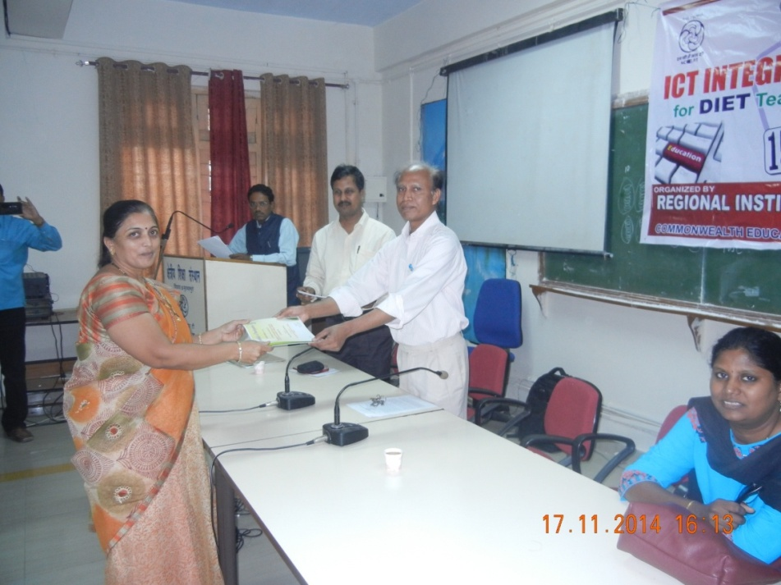

*Prof. J.Mandal, RIE, Bhopal distributing Certificates to the Participants*

* **Valedictory Address by Prof. J. Mandal, Professor of Science Education, RIE, Bhopal.**

Prof. J. Mandal explained the importance of training ICT to the teacher-educators. He also described the ICT activities of the RIE, Bhopal.

* **Vote of Thanks**

Dr. Ojha, proposed the vote of thanks.

**Annexure - 1: Programme Schedule**

**PROGRAMME SCHEDULE**

|  |  |
| --- | --- |
| **Session** | **Day 1: November 15, 2014** |
| **9:30 to 9: 45am** | **Registration** |
| **9:45 to 10:30am** | **Inaugural Session:**   * **Introductions of participants** * **Welcome Address by: Dr. N C Ojha, RIE-Bhopal** * **Remarks by: Dr. Manas Ranjan Panigrahi, Programme Officer Education, CEMCA, New Delhi** * **Address by Chief Guest** * **Inaugural Address by: Prof. H K Senapaty, Principal RIE-Bhopal** * **Vote of Thanks by: Dr. Ratnamal Arya, Associate Professor, RIE, Bhopal** |
| **10:30 to 10:45am** | **Health Break** |
| **10:45 to 11:30am** | **ICT in Education (Manas Ranjan)** |
| **11:30 to 1:00pm** | **Interactivity, Synchronous and Asynchronous Technologies; Online Tools for Teaching Learning (Mythili)** |
| **1:00 to 2:00pm** | **Lunch** |
| **2:00 to 3:15pm** | **Hands on Practice: Working collaboratively in Group using Synchronous and Asynchronous Technologies (Mythili)** |
| **3:15 to 3:30pm** | **Health Break** |
| **3:30 to 4:15pm** | **Understanding Open Educational Resources: Role in Teaching and Learning (Manas Ranjan)** |
| **4:15 to 5:30pm** | **CEMCA Community of Practice for Teacher Educators (Mythili)** |
| **Session** | **Day 2: November 16, 2014** |
| **9:30 to 10:30am** | **Teacher Activities supported by ICT: Curriculum planning, Instructional design, Content delivery, Student Assessment; recent trends in online education (Mythili)** |
| **10:30 to 10:45am** | **Health Break** |
| **10:45 to 11:30am** | **Hands on Practice and session continue (Mythili)** |
| **11:30 to 1:00pm** | **Using Social Media: Overview on Facebook, Twitter, Google hangouts, You Tube, Photosharing (Mythili)** |
| **1:00 to 2:00pm** | **Lunch** |
| **2:00 to 3:15pm** | **Using Wikis and Blogs (Mythili)** |
| **3:15 to 3:30pm** | **Health Break** |
| **3:30 to 4:15pm** | **Preparing teaching content: Using Audio/Podcasts/ Video/Vodcasts (Mythili)** |
| **4:15 to 5:30pm** | **Hands on Practice: Creating audio resources and podcasts (Mythili)** |
| **Session** | **Day 3: November 17, 2014** |
| **9:30 to 10:30am** | **Creative Commons Licences (Manas Ranjan)** |
| **10:30 to 10:45am** | **Health Break** |
| **10:45 to 1:00pm** | **Collaborative practices: Google Docs (Mythili)** |
| **1:00 to 2:00pm** | **Lunch** |
| **2:00 to 3:15pm** | **Student Assessment using ICT, including ePortfolio, creating quizzes (Hot Potato); Refinement of products created by participants as hands on practice (Mythili)** |
| **3:15 to 3:30pm** | **Health Break** |
| **3:30 to 4:30pm** | **Presentation of work created collaboratively and as group activity by participants (Mythili)** |
| **4:30 to 5:30pm** | **Valedictory Session:**   * **Report by workshop coordinator: Dr. N C Ojha, RIE-Bhopal** * **Remarks by: Ms. GMythili, IGNOU and Dr. Manas Ranjan Panigrahi, Programme Officer Education, CEMCA** * **Feedback by participants** * **Distribution of Certificates** * **Valedictory Address by Prof. J. Mandal, Professor of Science Education, RIE, Bhopal** * **Vote of Thanks by** **Dr. N C Ojha, RIE-Bhopal** |

**Annexure – 2: List of Participants**

**List of Participants**

1. K. K. Dixit, DIET, Shivpuri
2. Fateh Singh Sehra, DIET, Shahdol
3. Dinesh Singh Bhadoria, DIET, Bhind
4. Sanjeev Kumar Dwivedi, DIET, Satna
5. Roop Singh Bamaniya, DIET, Alirajpur
6. G.P. Tripathi, DIET, Rewa
7. Vijay KrishanShukla, DIET, Sidhi
8. M.S. Parmar, DIET, Morena
9. Ashok Wanhere, DIET, Khandwa
10. Nishi Sharma, DIET, Bhopal
11. Goverdhan Budholia, DIET, Bajranggarh
12. Hema Khare, DIET, Ujjain
13. Dr. Phool Singh Narwaria, DIET, Gwalior
14. Ved Prakash Gupta, DIET, Mandla
15. Ajay Kumar Sharma, DIET, Sehore
16. Sharda Mamtani, DIET, Raisen
17. Anubha Gupta, DIET,Vidisha
18. Surekha Anwekar, DIET, Indore
19. Sadhana Bhawar, DIET, Barwani
20. Taruna Sharma, DIET, Jabalpur
21. M.K. Rawat, DIET, Sagar
22. Girish Kumar Gupta, DIET, Kahrgone

**Annexure - 3: Workshop Evaluation**

|  |  |  |
| --- | --- | --- |
|  | **Workshop on ICT Integrated Teacher Education**  **for DIET Teacher Educators of Madhya Pradesh**  **15-17 November 2014**  **Organised by**  **Regional Institute of Education, NCERT, Bhopal**  **In Collaboration with**  **Commonwealth Education Media Center of Asia, New Delhi** | http://jobsrock.in/wp-content/uploads/2014/04/NCERT-delhi-logo.png |

**Workshop Evaluation**

Please provide your feedback on the workshop that you have attended on “Workshop on ICT Integrated Teacher Education” from 15thto 17thNovember 2014 at RIE, Bhopal.

1. **Your overall reaction on this workshop:**

Very good Good Fair Poor Very Poor

1. **The Workshop met my expectations:**

To a large extent Up to certain extant Poor Not to all

1. **The duration of workshop:**

Too long Sufficient Too short

1. **Logical sequence of the workshop was:**

Very useful Somewhat useful Not very Useful Not at all useful

1. **Overall organization arrangements:**

Very good Good Fair Poor Very Poor

1. **Number Of trainers involved:**

Too many Just right Too few

1. **Kindly rate in general the effectiveness of the trainers:**

**Very Somewhat Somewhat Not**

**Effective Effective Not Effective Effective**

|  |
| --- |
|  |

1. Knowledge of the subject matter
2. Organization and Presentation
3. Style and delivery
4. Responsive to participants
5. Creating appropriate learning

environment

1. **Sufficient of the training material supplied:**

Sufficient Somewhat sufficient Not sufficient Not all sufficient

1. **To what extent the workshop was helpful in the following area:**

**To large Somewhat Poor Not at**

**Extent all**

|  |
| --- |
|  |

1. Understanding in ICTin

Education : History &development

Theoretical framework and ICT

Competency of Teacher Educator

(UNESCO framework)

1. Understanding CEMCA community

of practice for teacher Educator

1. Creations of account and user page on

MediaWiki(WikiEducator)

1. Understanding ICT tool for

Teaching and learning

1. Preparing teaching content

Using audio and video

1. Using social media for teaching

And learning

1. Understanding open licenses
2. Collaborative practice using

Google Drive, Google Docs

Google Calendar

1. **Mix of theory and practical in the workshop:**

Too Theoretical Good Balance Too Practical

1. **Did you have sufficient time for skill practice?**

Yes No

1. **Value of workshop to immediate/future work :**

Very Valuable Somewhat Valuable Somewhat Not Valuable Not Valuable

1. **Your Comments/Suggestion, if any:**
2. The workshop can be organized for 5–7 days; in order to have detailed discussions as well as more time can be devoted for the hands-on practices.
3. They were of the view that the workshop is useful for the teacher-educators as well as the teachers.
4. In order to apply all these knowledge in the real field, the DIETs should be equipped with the more infrastructural facilities like the required number of computers, smart board, LCDs, etc.
5. Time to time, this type of workshop/orientation programmes may be organized for the teacher-educators, in order to renew and revive the experiences as well as apply those in the real classroom situation.
6. Even an aged-participant was of the opinion that the workshop was so interesting that he never felt tired during the entire workshop period.
7. All of them viewed that these types of workshop/orientation would boost and encourage them to work on the ICT integration in content and pedagogy as well to carry out innovative practices in the field of education.

